**EXPERIMENT-1**

Write an HTML code to display your CV on web page.

CODE:

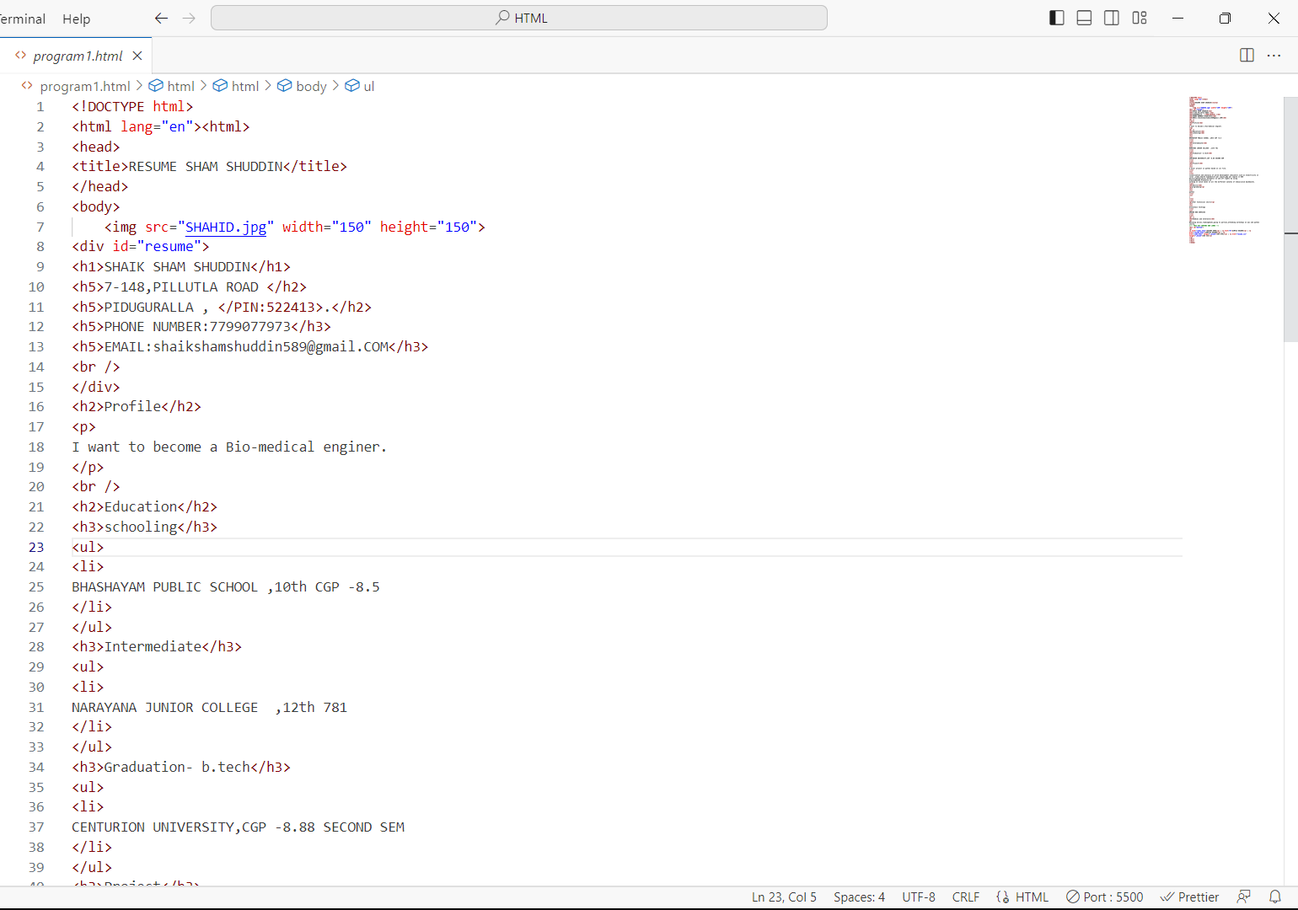

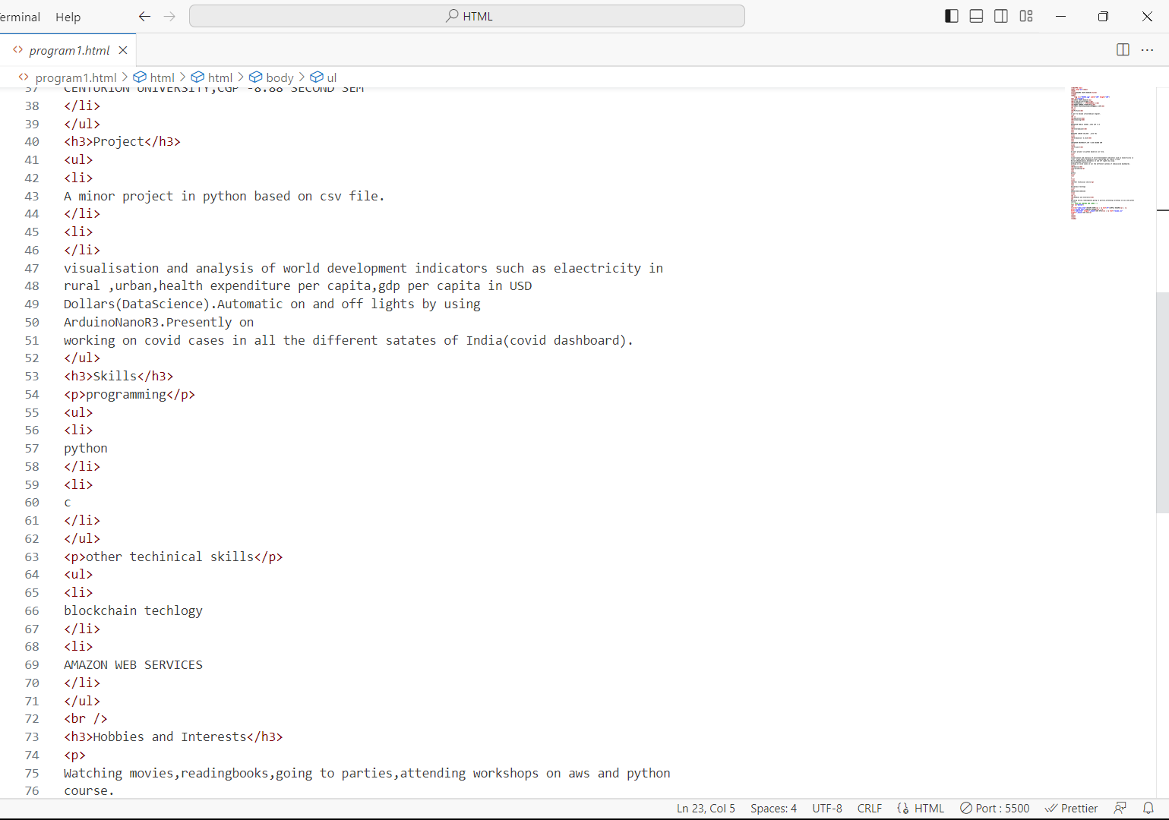

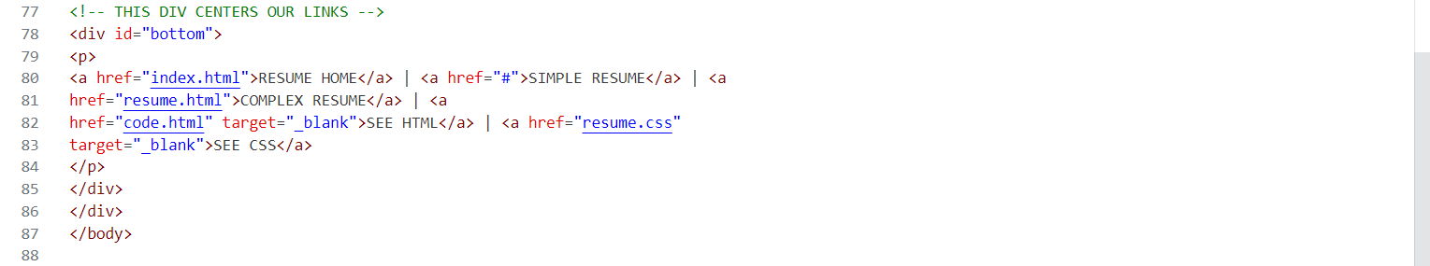

OUTPUT:

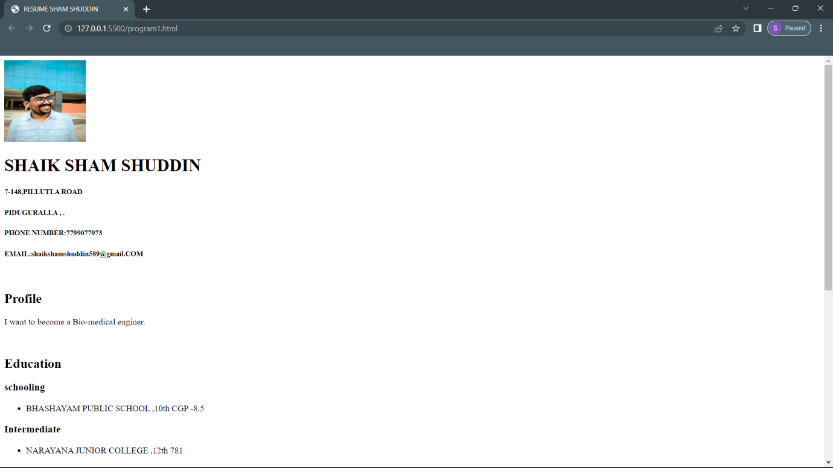

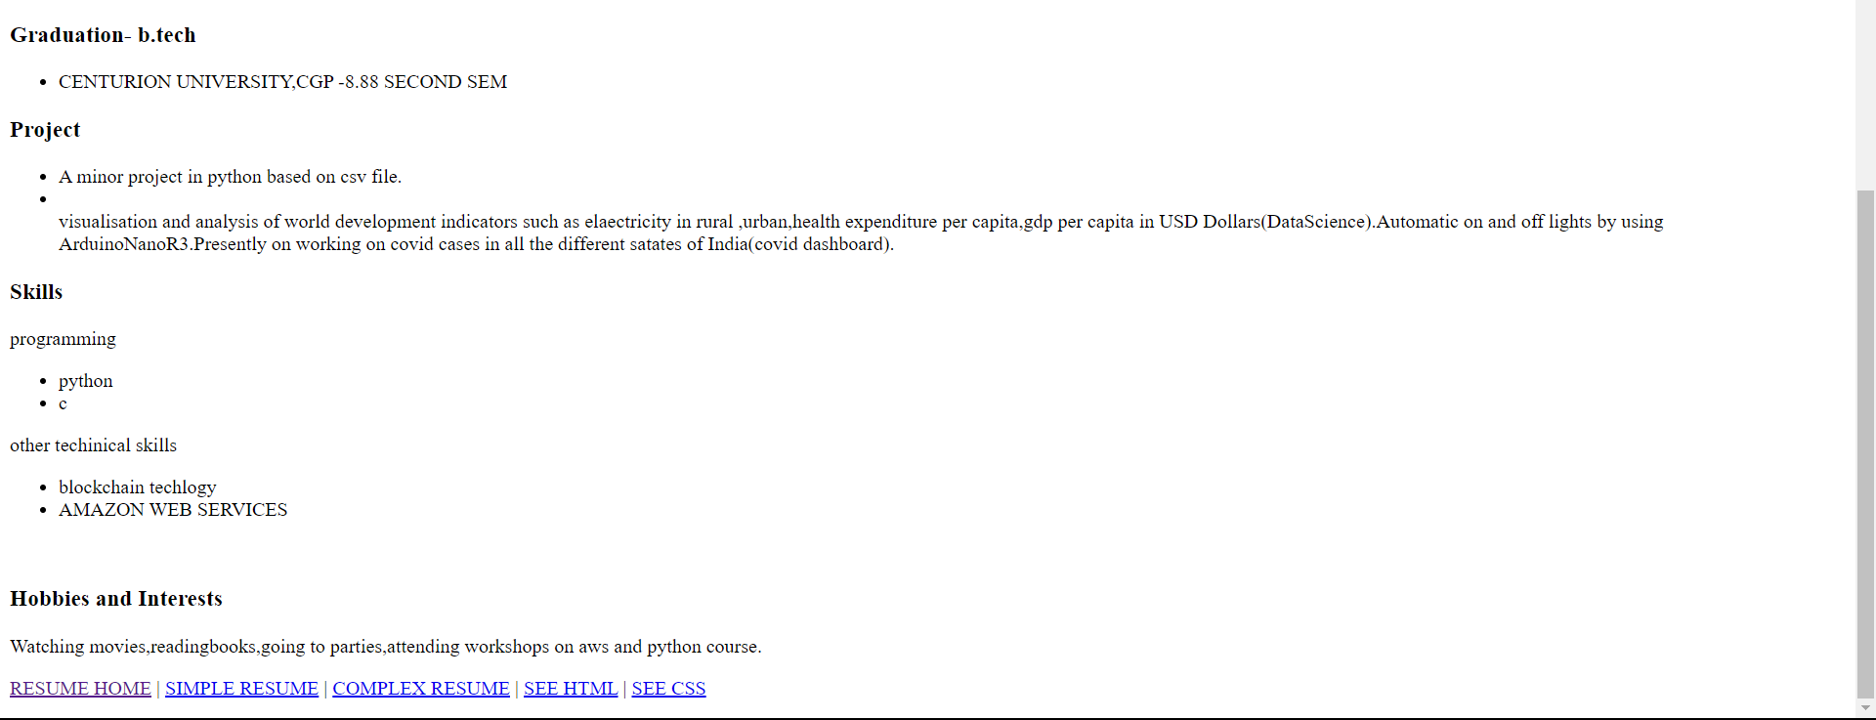

**EXPERIMENT-2**

Ml code to create a Home page having three links: About Us, Our Services and Contact Us.Create separate web pages for the three links.

**CODE:**

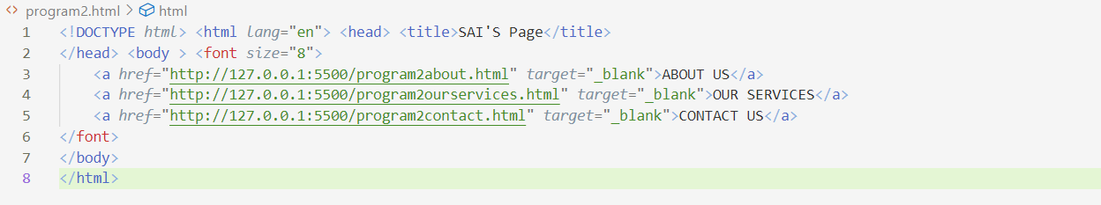

**2.1**

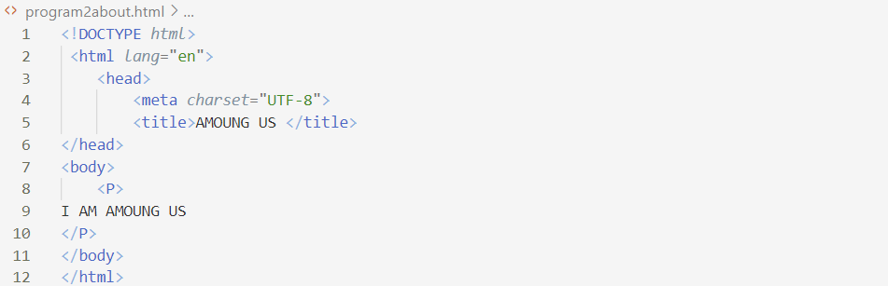

**2.2**

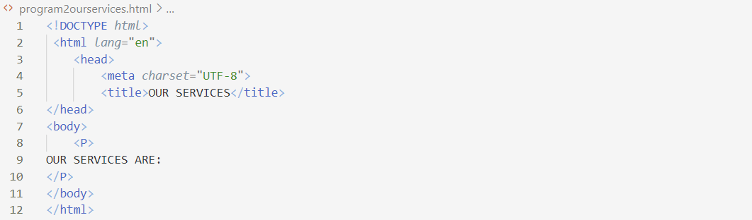

**2.3**

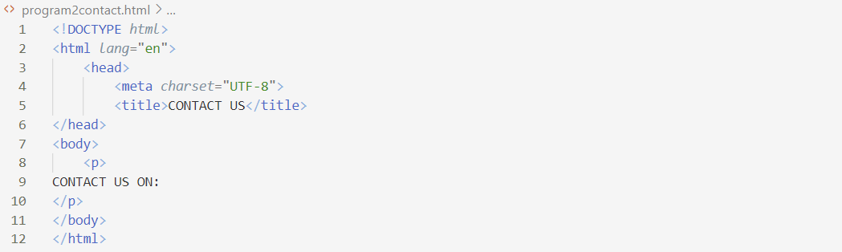

**OUTPUT:**

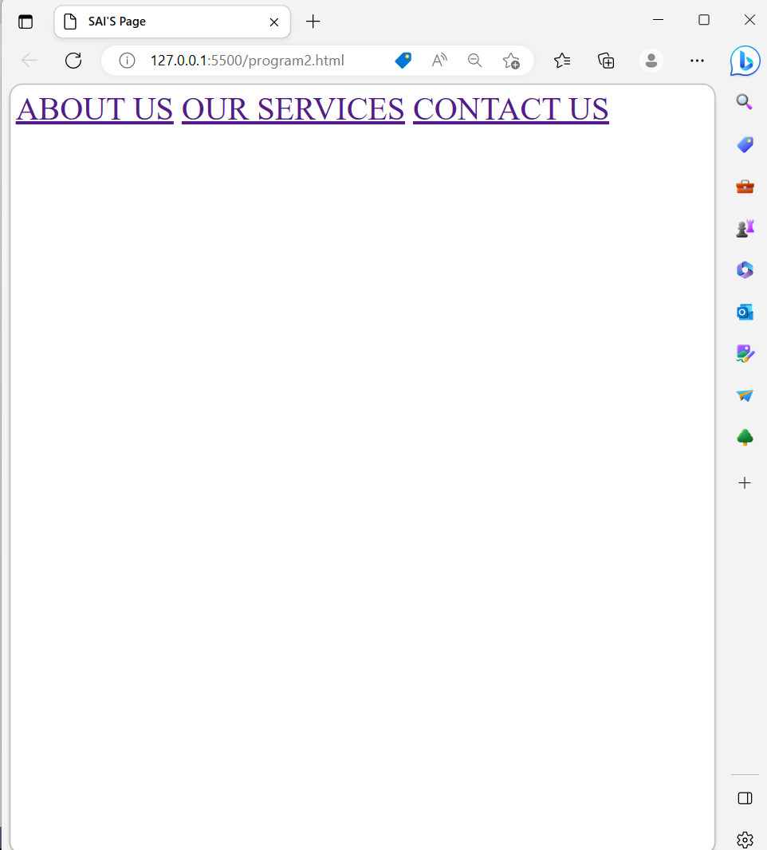

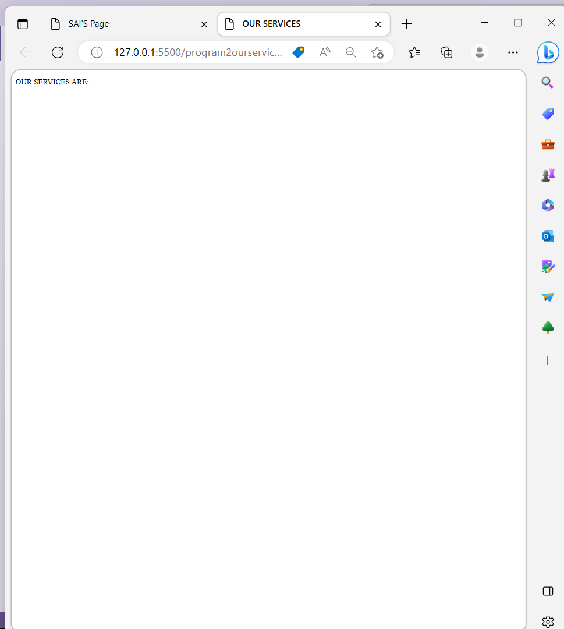

**EXPERIMENT-3**

Write an HTML code to create a Registration Form. On submitting the form, the user should be asked to login with this new credentials.

**CODE:**

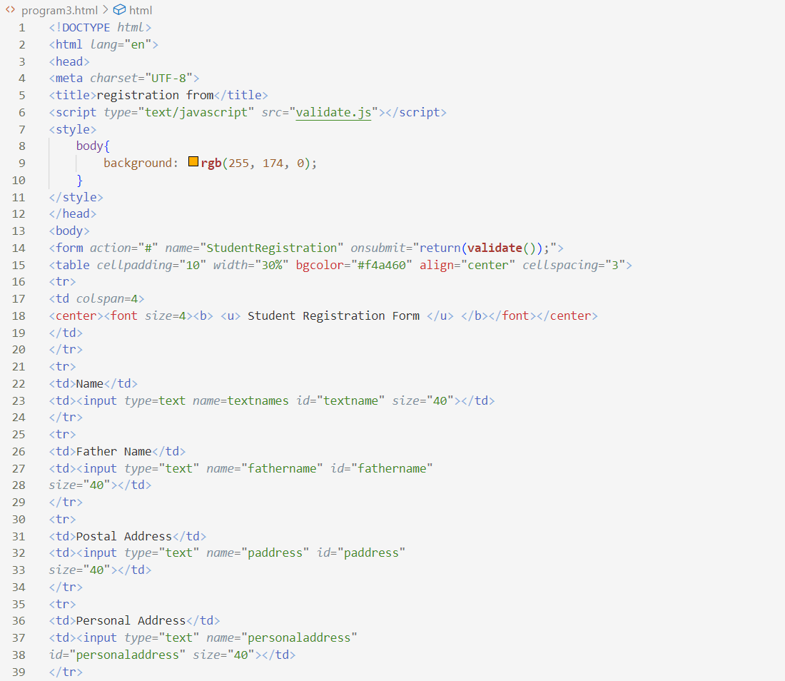

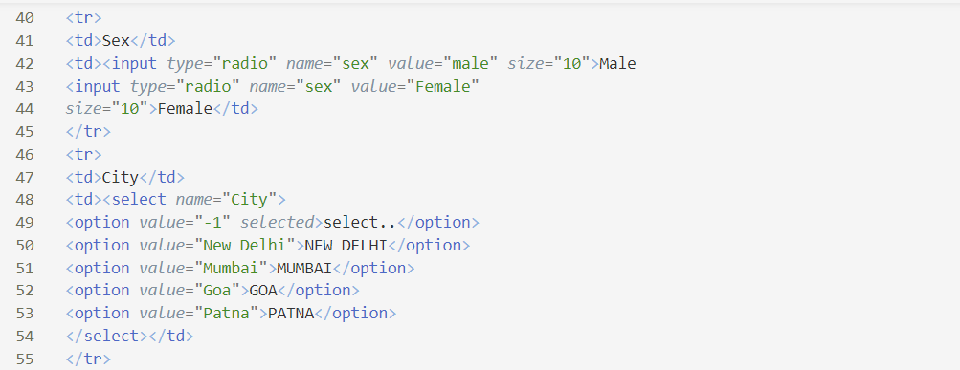

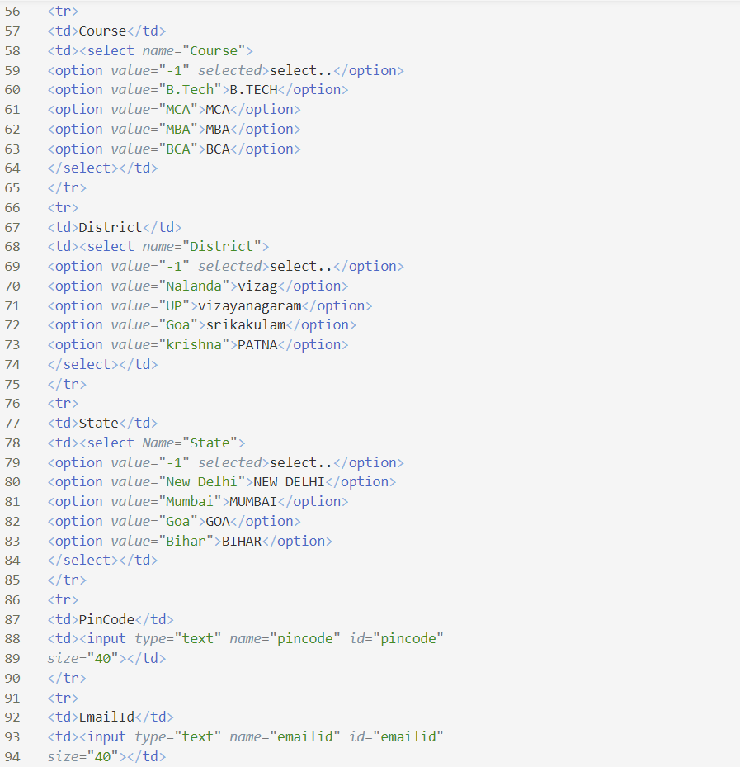

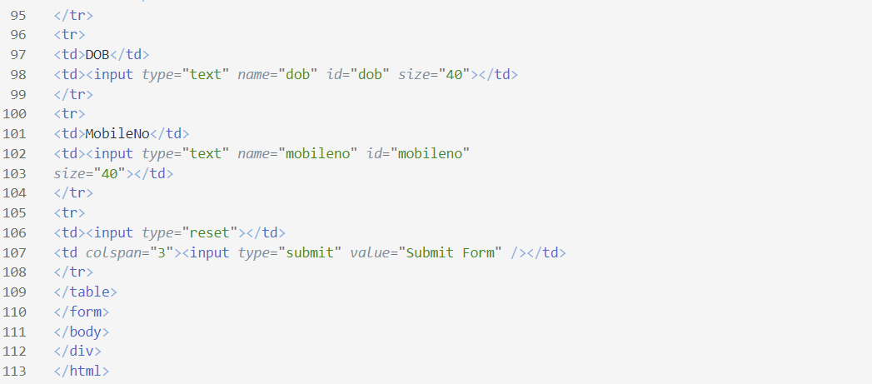

**OUTPUT:**

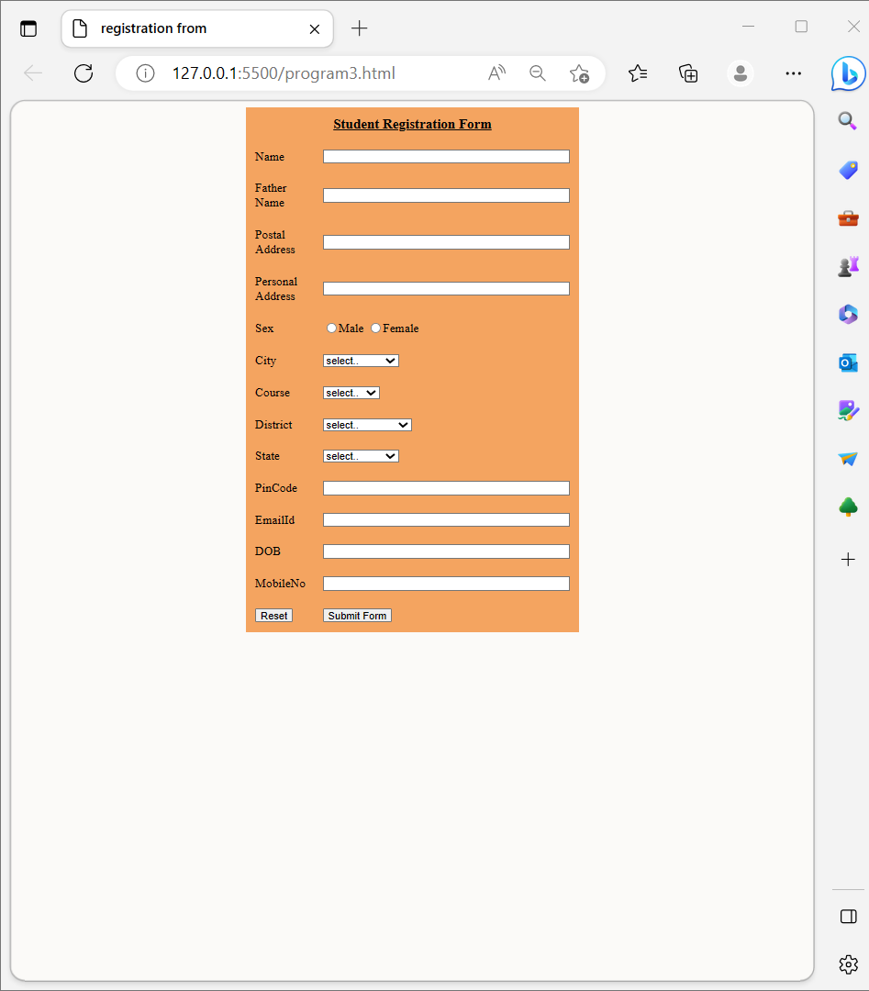

**EXPERIMENT-4:**Write an HTML code to create your Institute website, Department Website and Tutorial website for specific subject.

**CODE:**

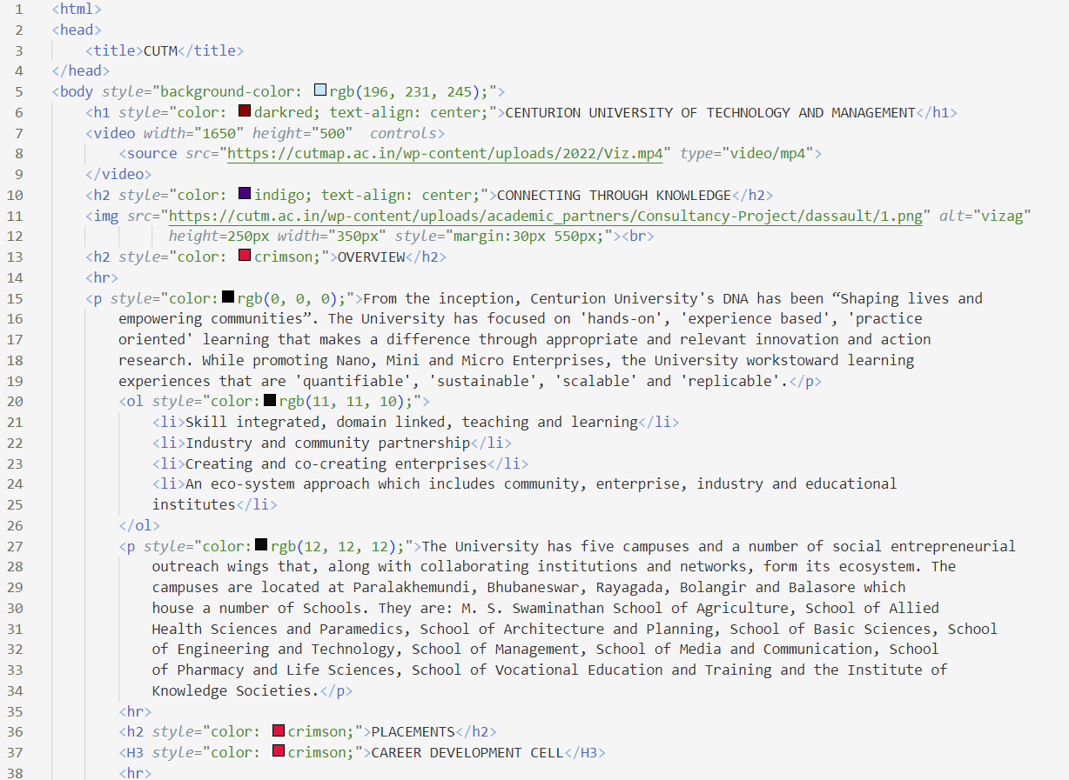

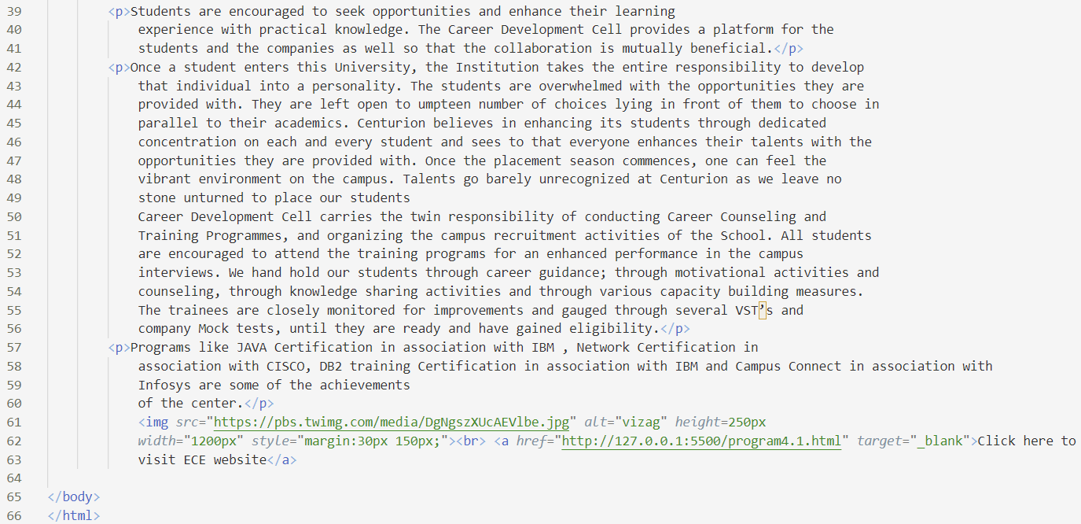

4.1

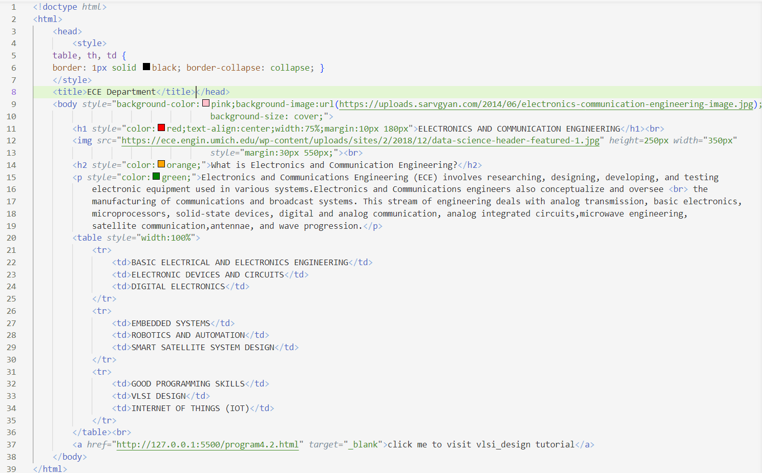

4.2

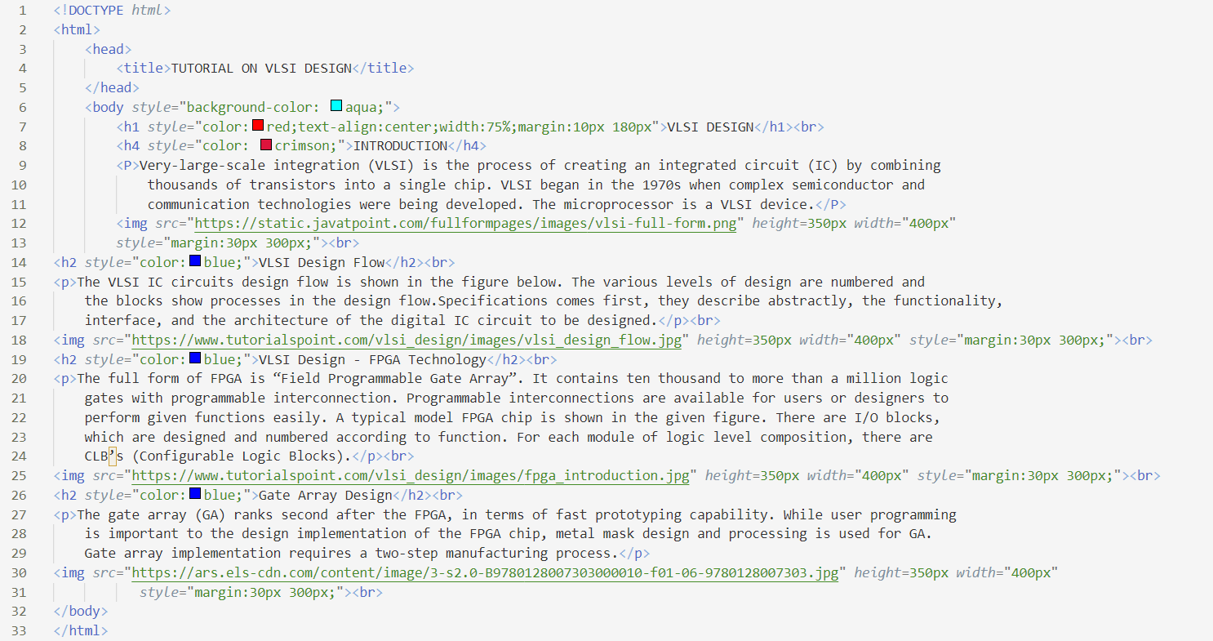

**OUTPUT:**

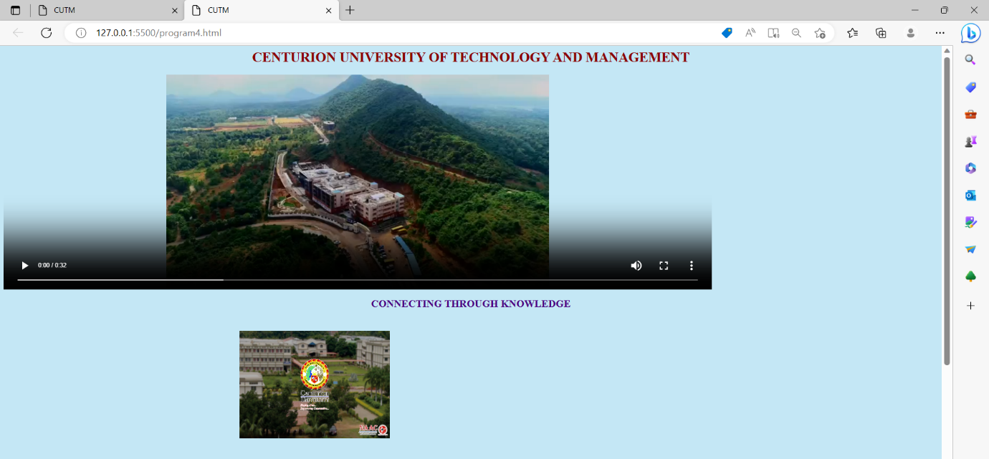

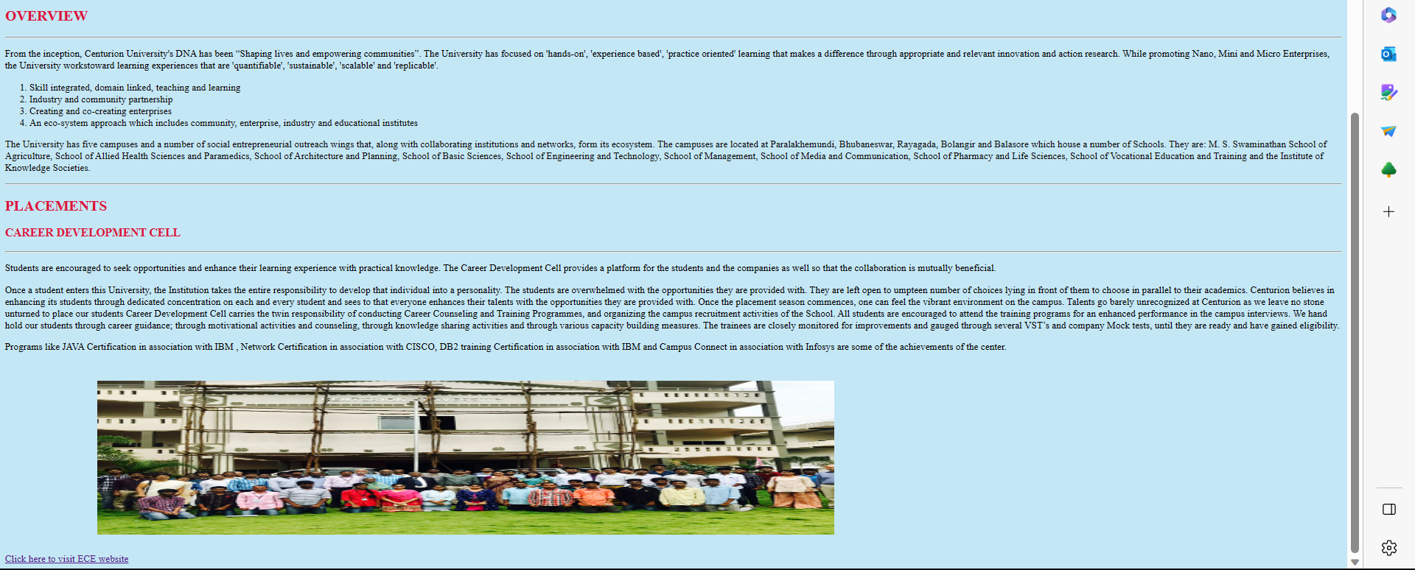

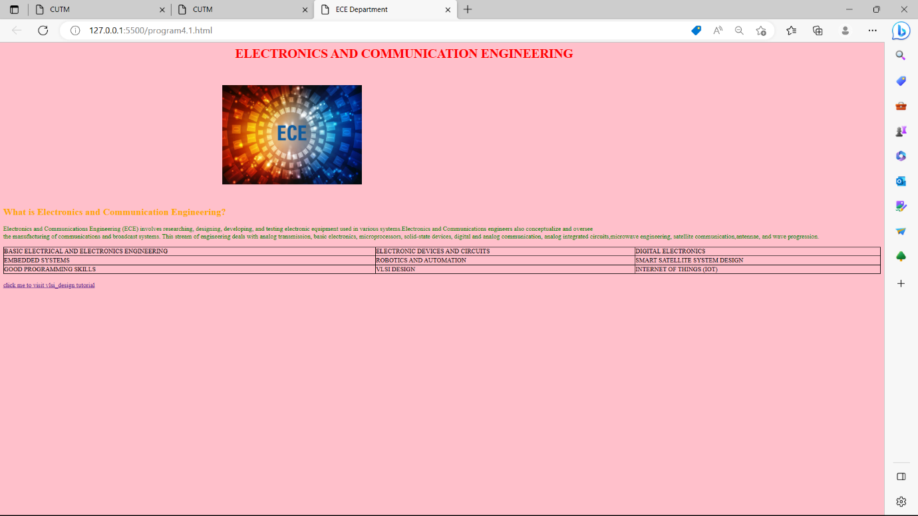

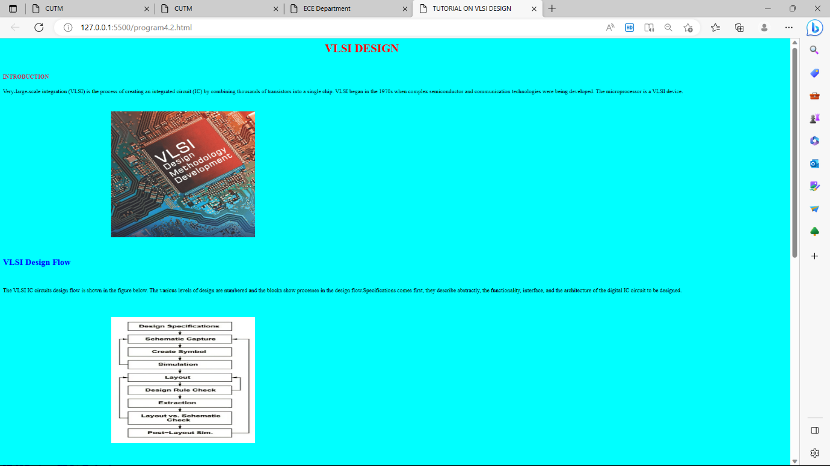

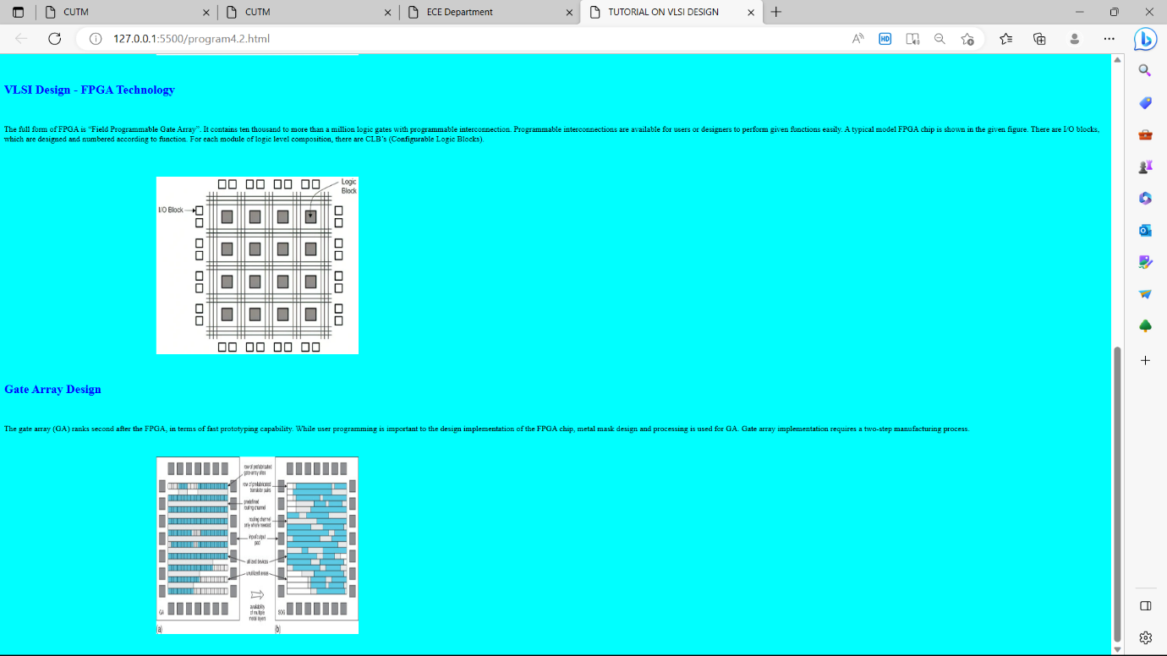

**EXPERIMENT-5:** Write an HTML code to create a frameset having header, navigation and contentsections.

**CODE:**

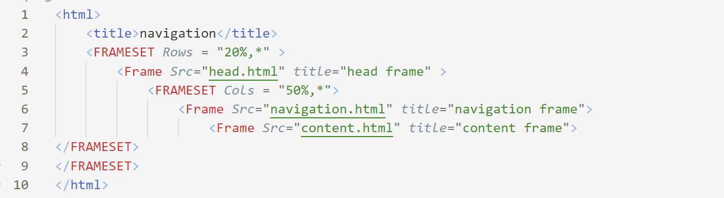

**OUTPUT:**

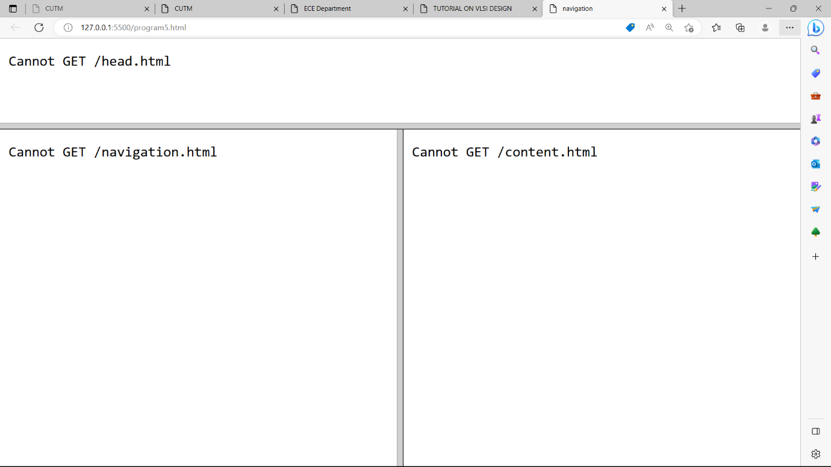

**EXPERIMENT-6:** .Write an HTML code to demonstrate the usage of inline CSS.

**CODE:**

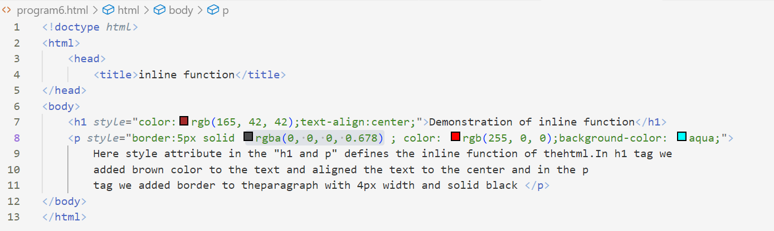

**OUTPUT:**

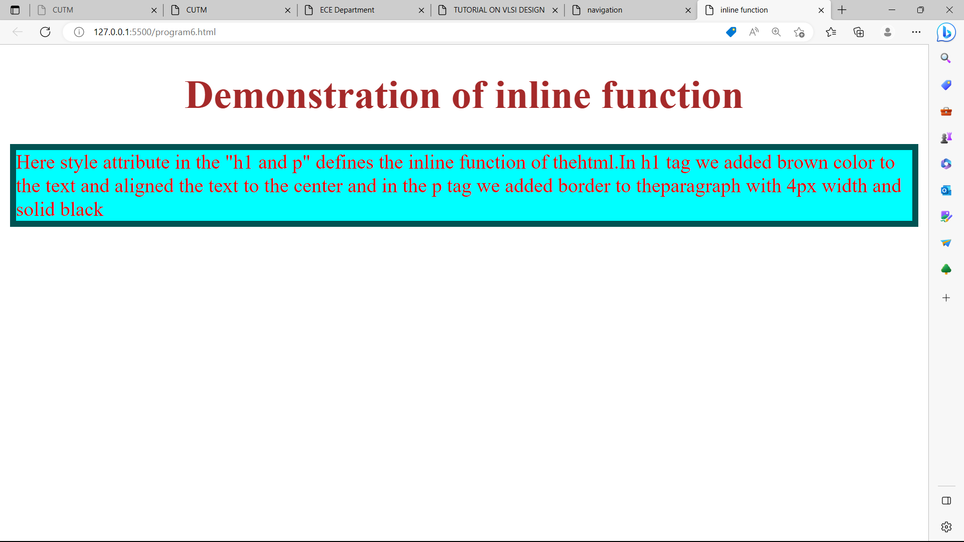

**EXPERIMENT-7:** Write an HTML code to demonstrate the usage of internal CSS.

**CODE:**

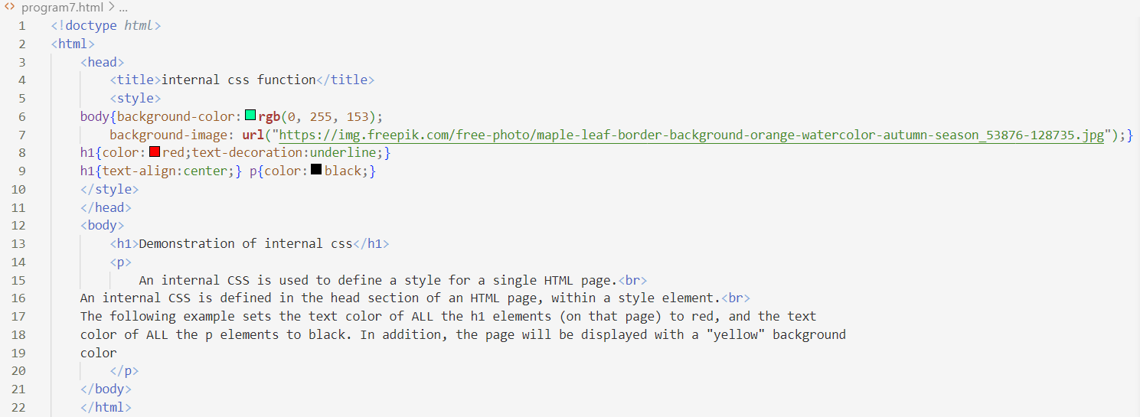

**OUTPUT:**

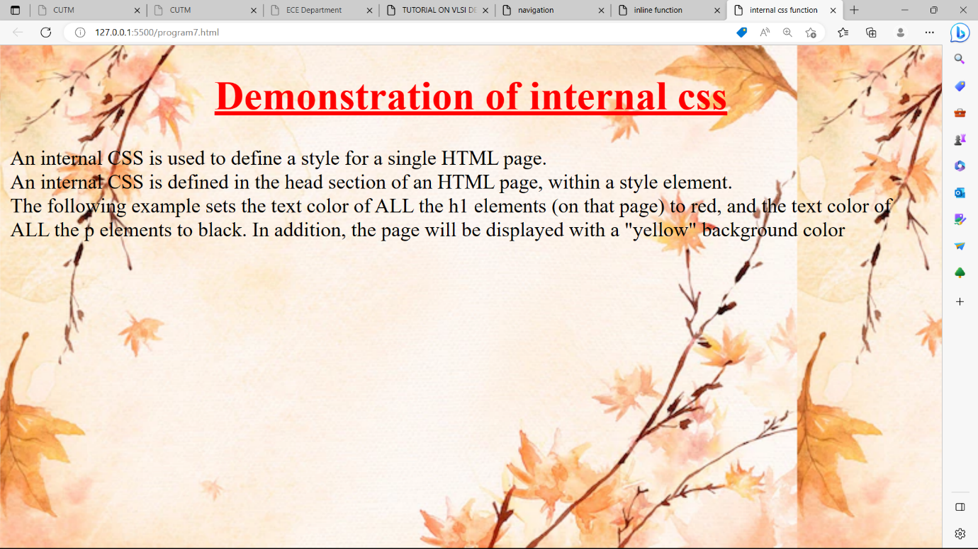

**EXPERIMENT-8:** Write an HTML code to demonstrate the usage of external CSS.

**CODE:**

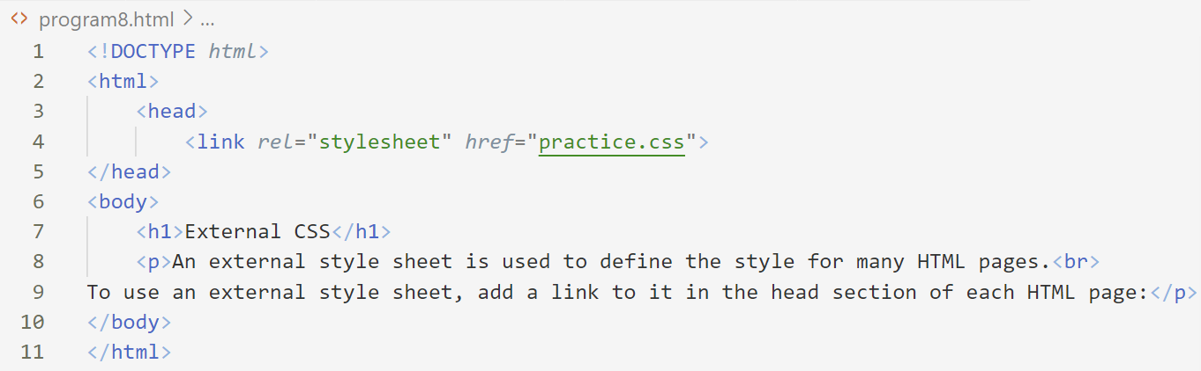

**OUTPUT:**

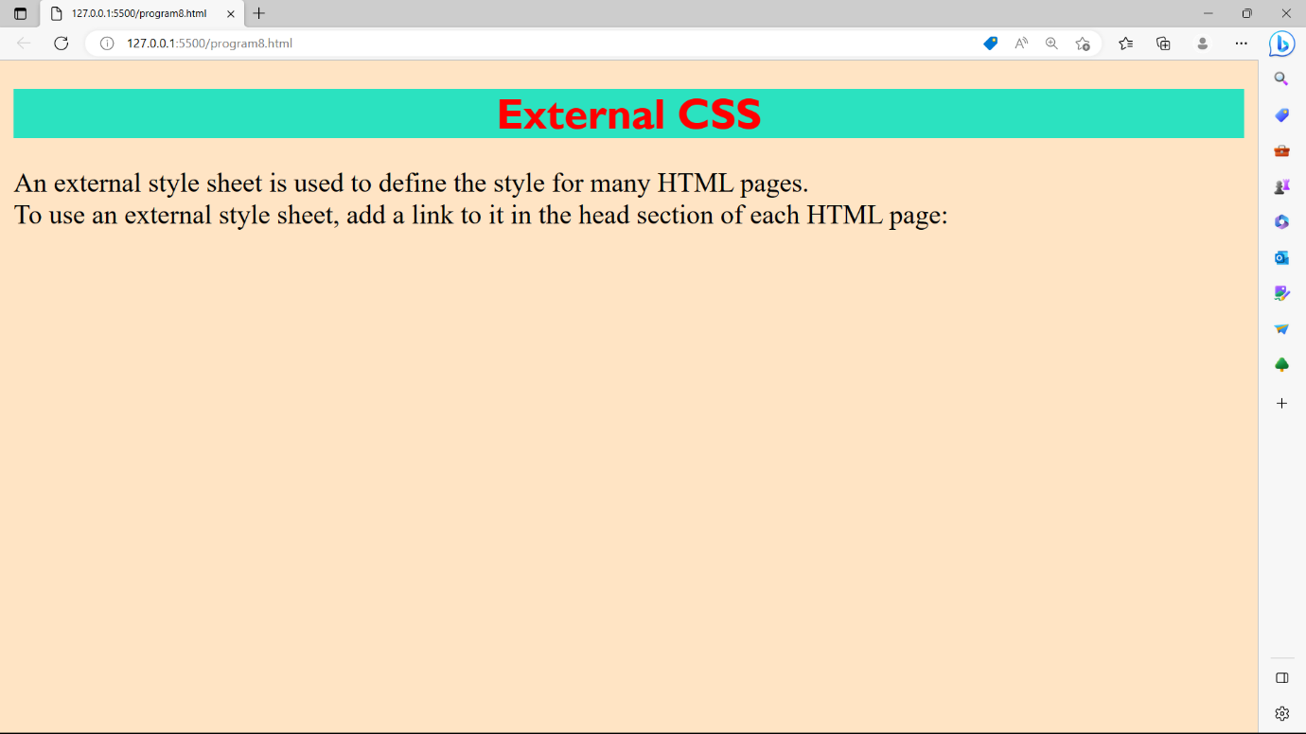

**EXPERIMENT-9:** Design your own website using HTML CSS.

**CODE:**

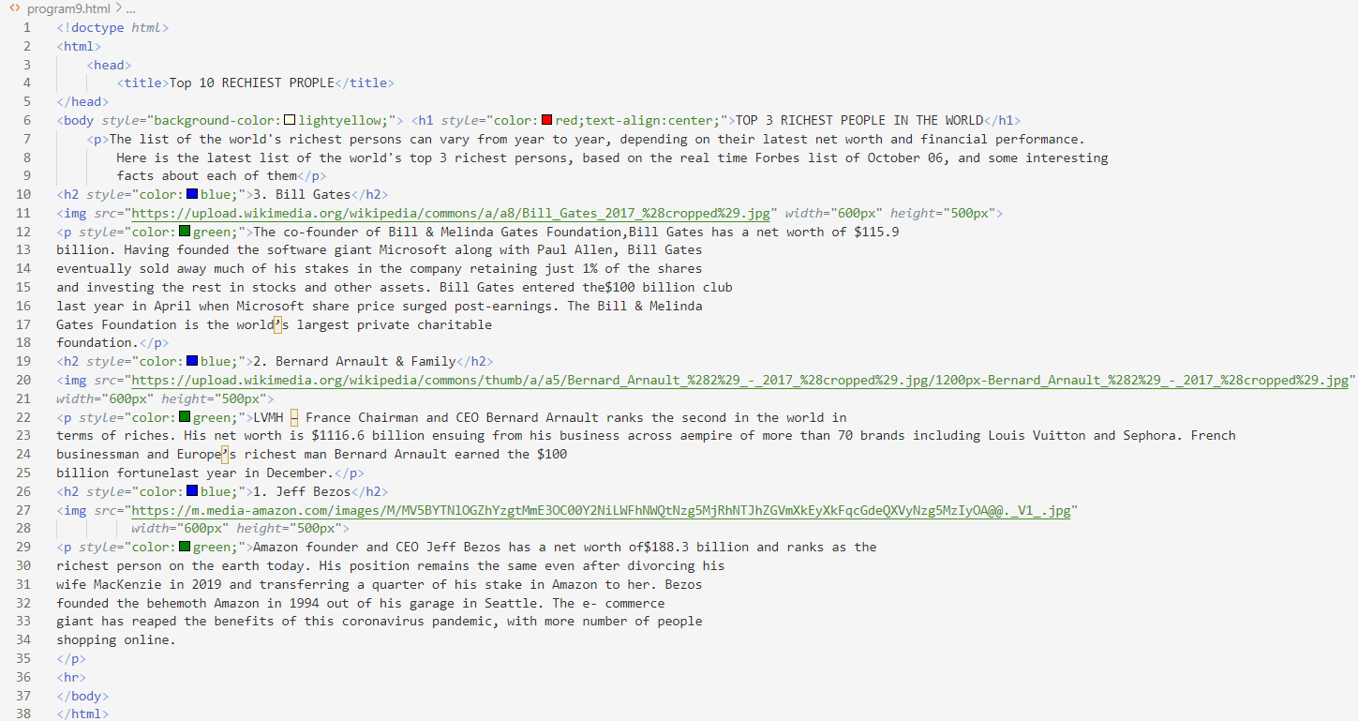

**OUTPUT:**

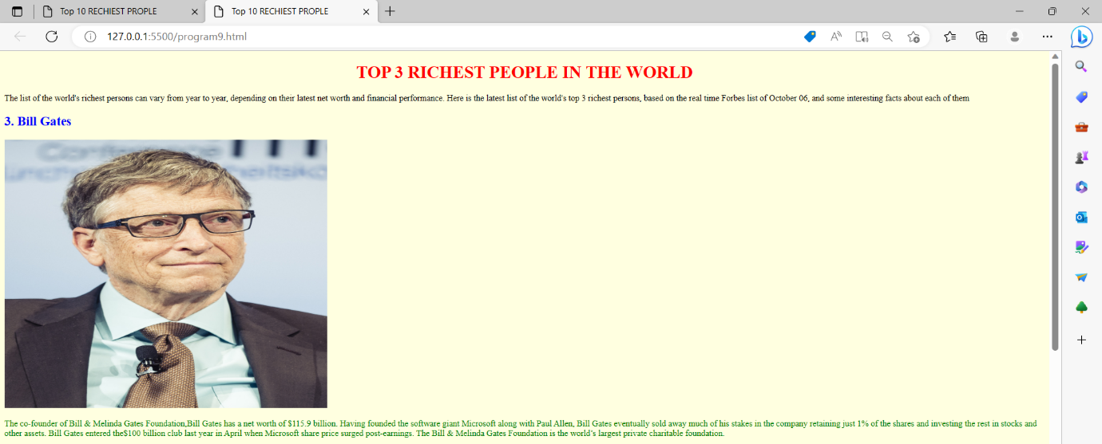

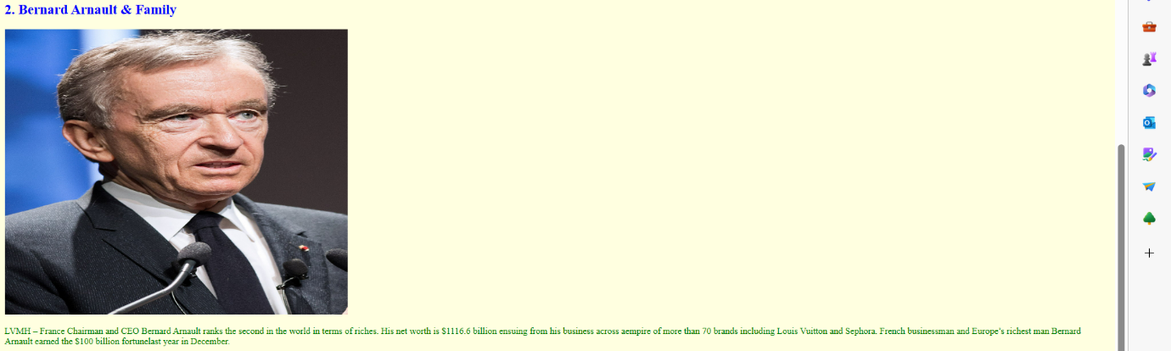

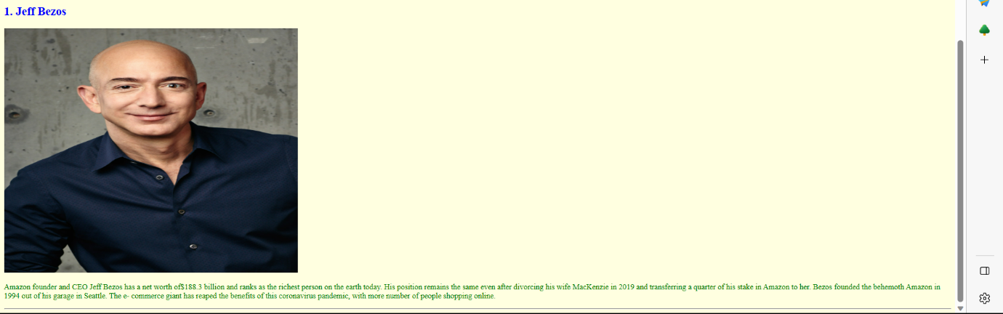

**EXPERIMENT-10:** Design form using HTML and apply CCS.

**CODE:**

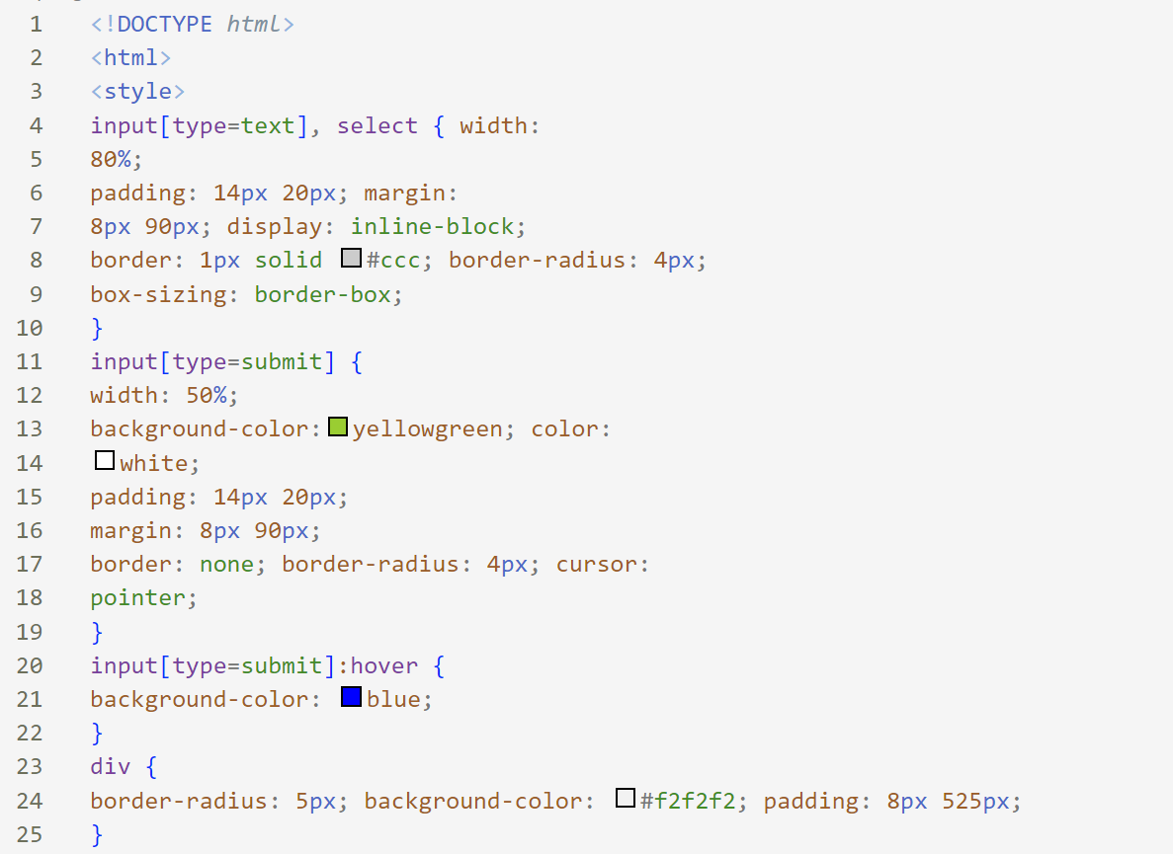

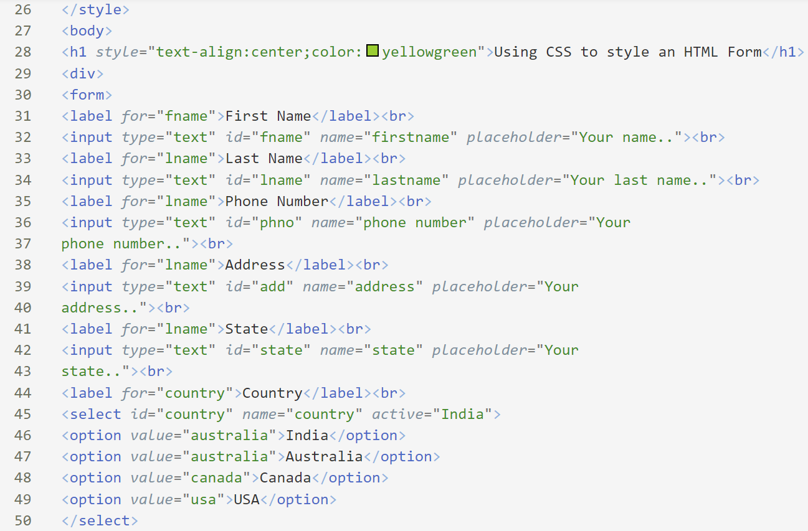

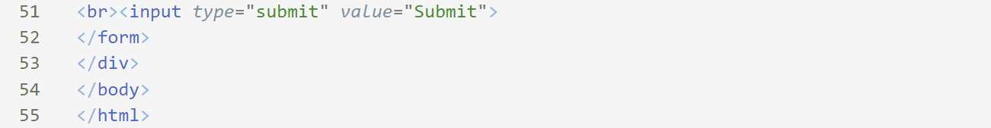

**OUTPUT:**

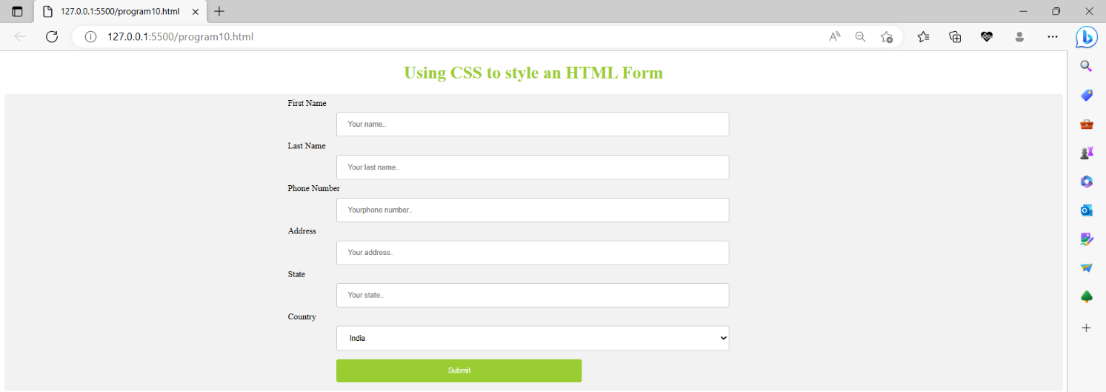

**EXPERIMENT-11:** Write a Java script to prompt for users name and display it on the screen.

**CODE:**

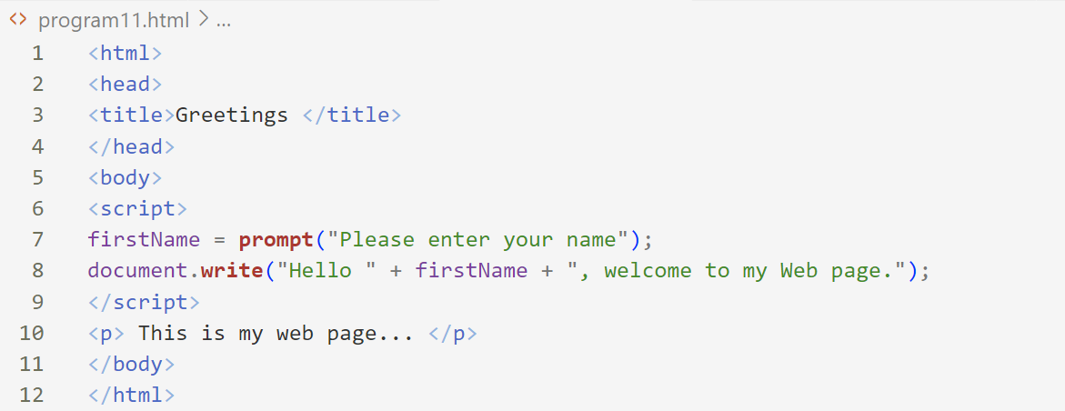

**OUTPUT:**

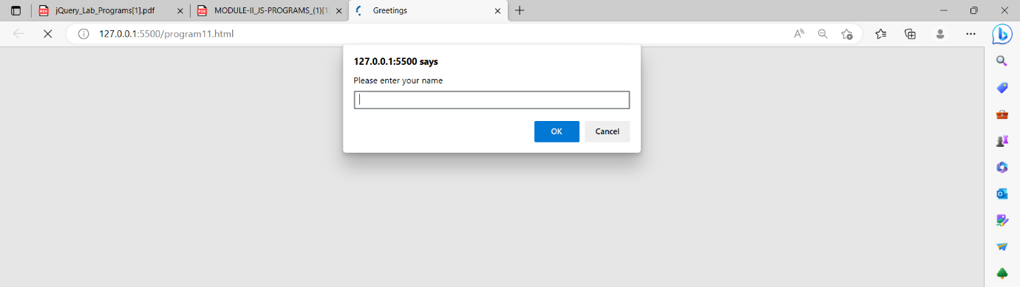

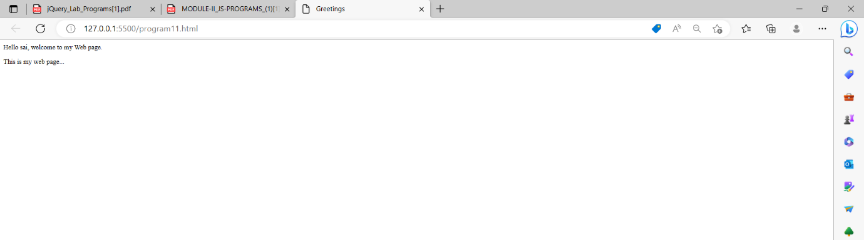

**EXPERIMENT-12:** Design HTML form for keeping student record and validate it using Java script. **CODE:**

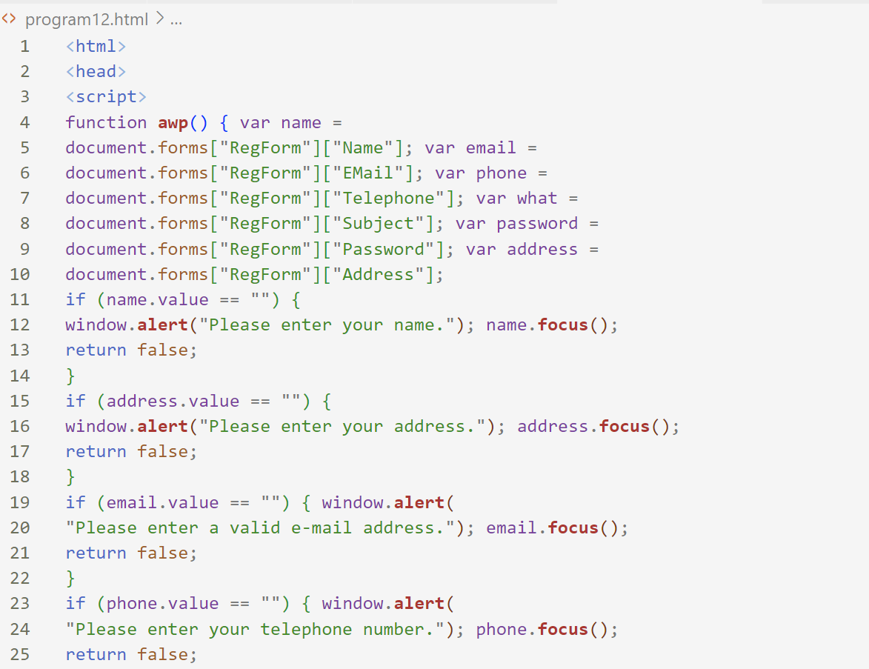

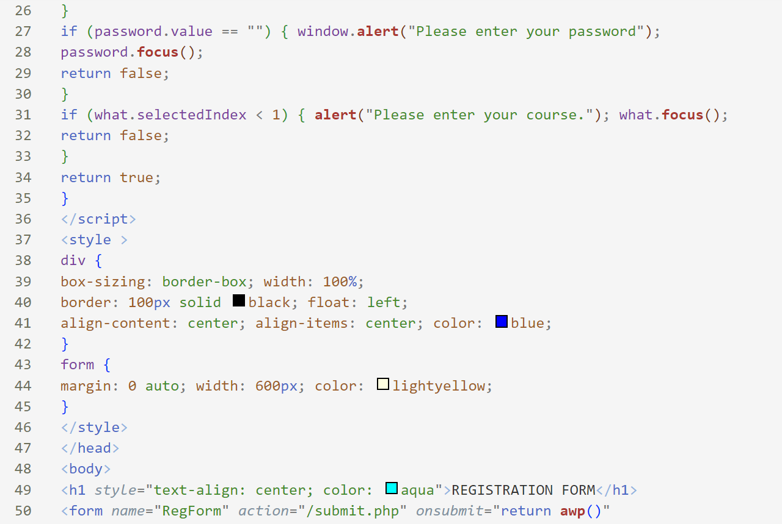

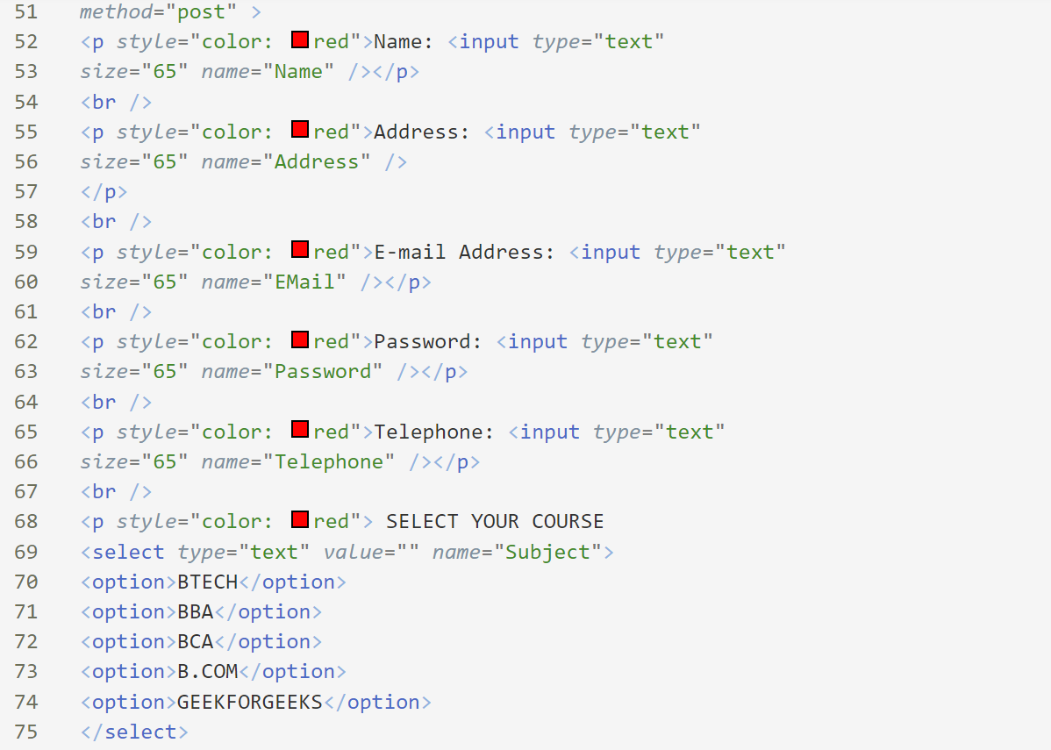

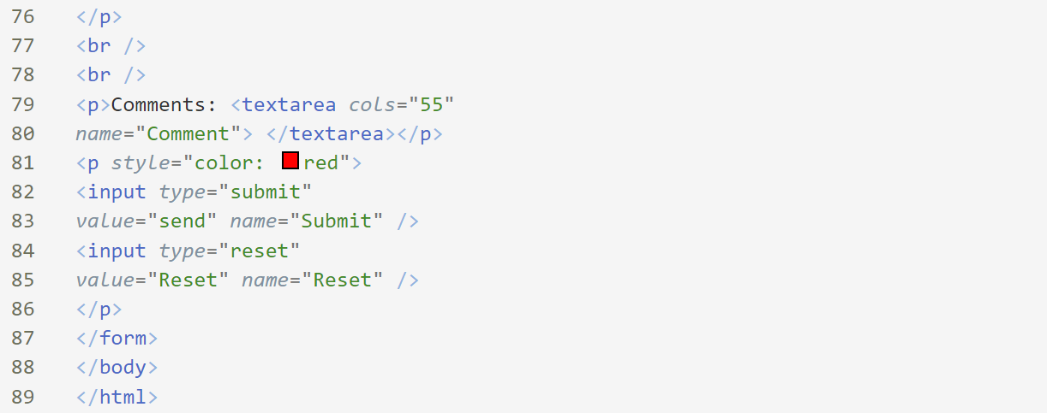

**OUTPUT:**

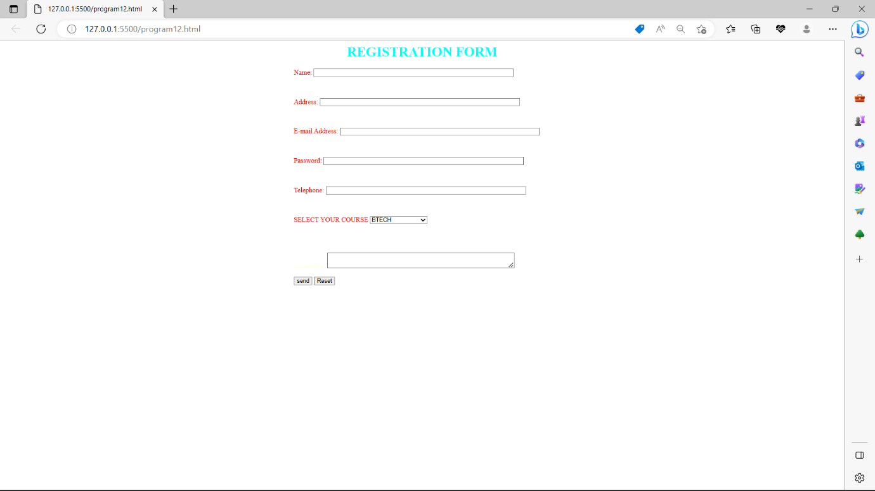

**EXPERIMENT-13:** .Write programs using Java script for Web Page to display browsers information.

**CODE:**

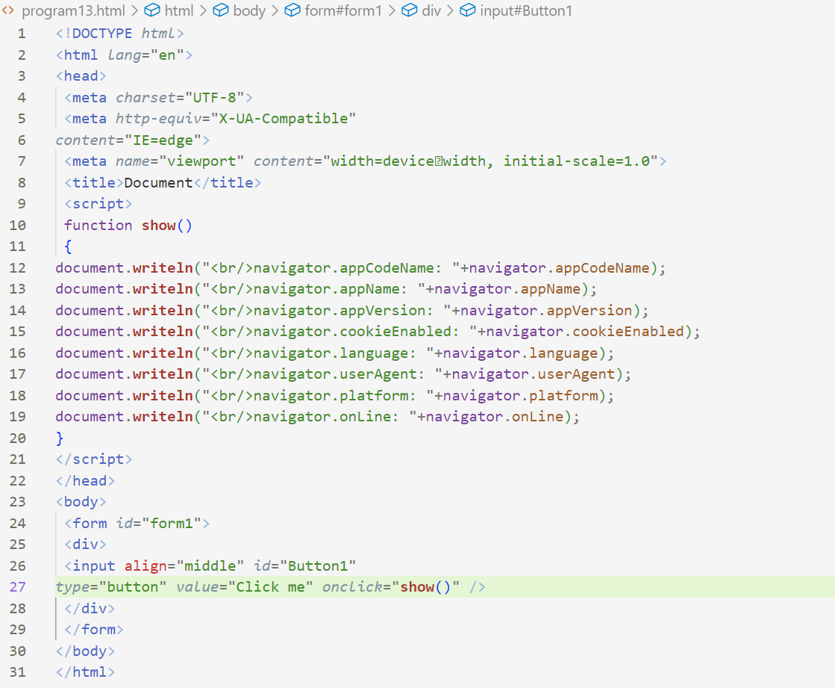

**OUTPUT:**

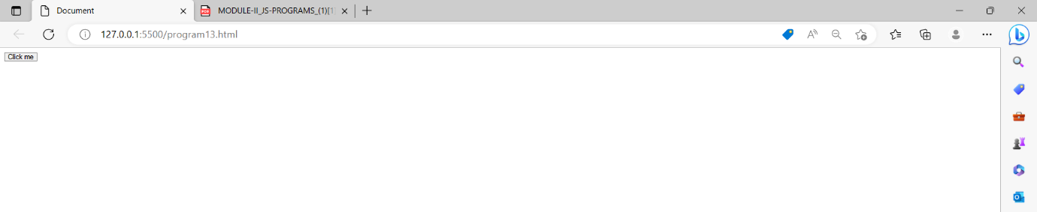

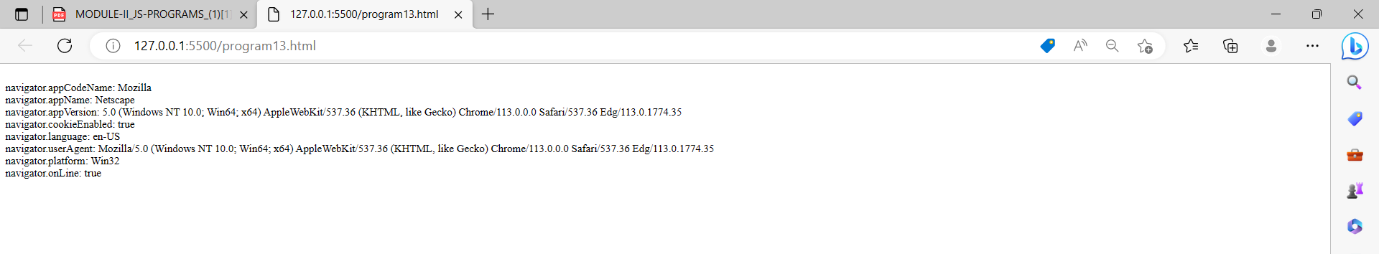

**EXPERIMENT-14:** Validate form page using JavaScript

**CODE:**

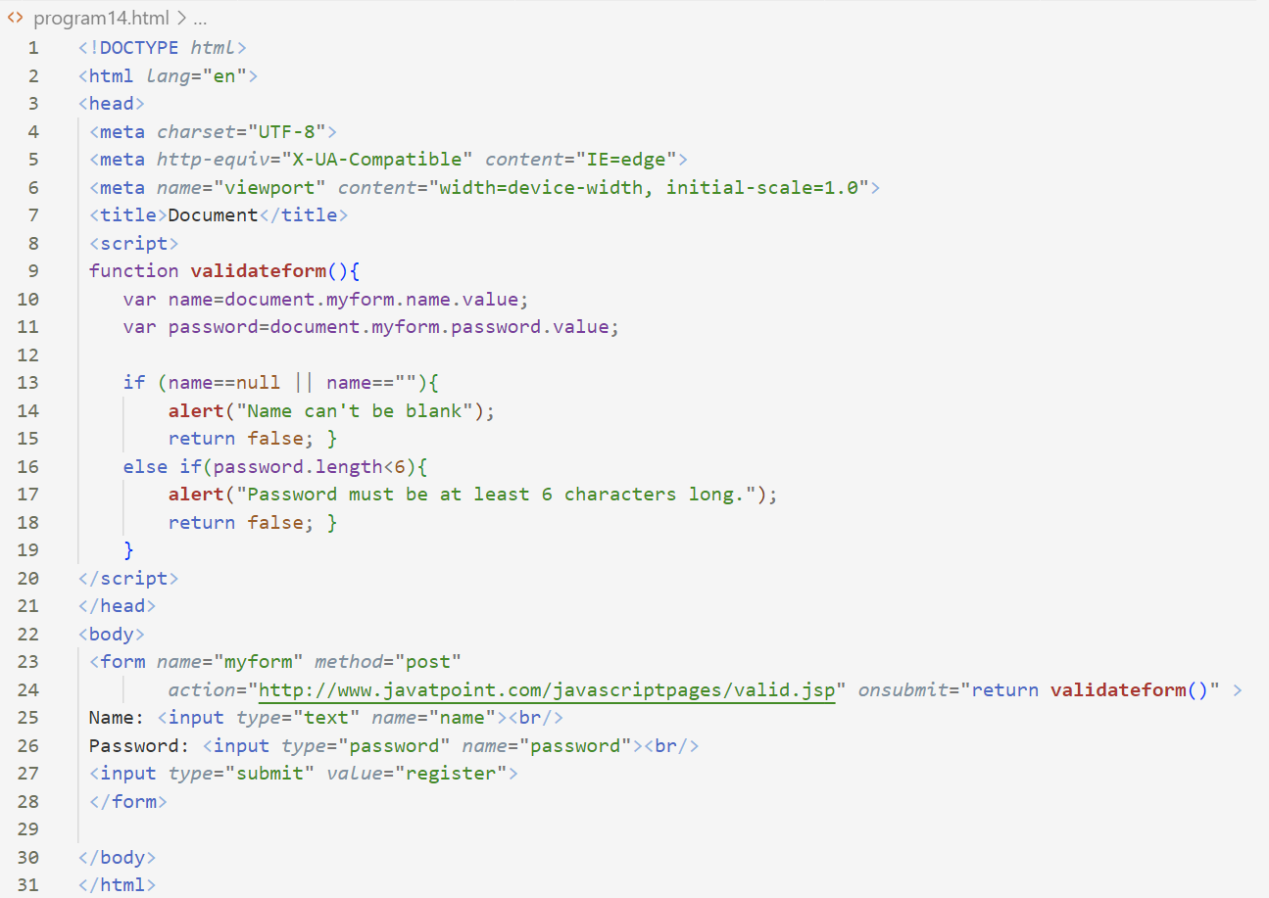

**OUTPUT:**

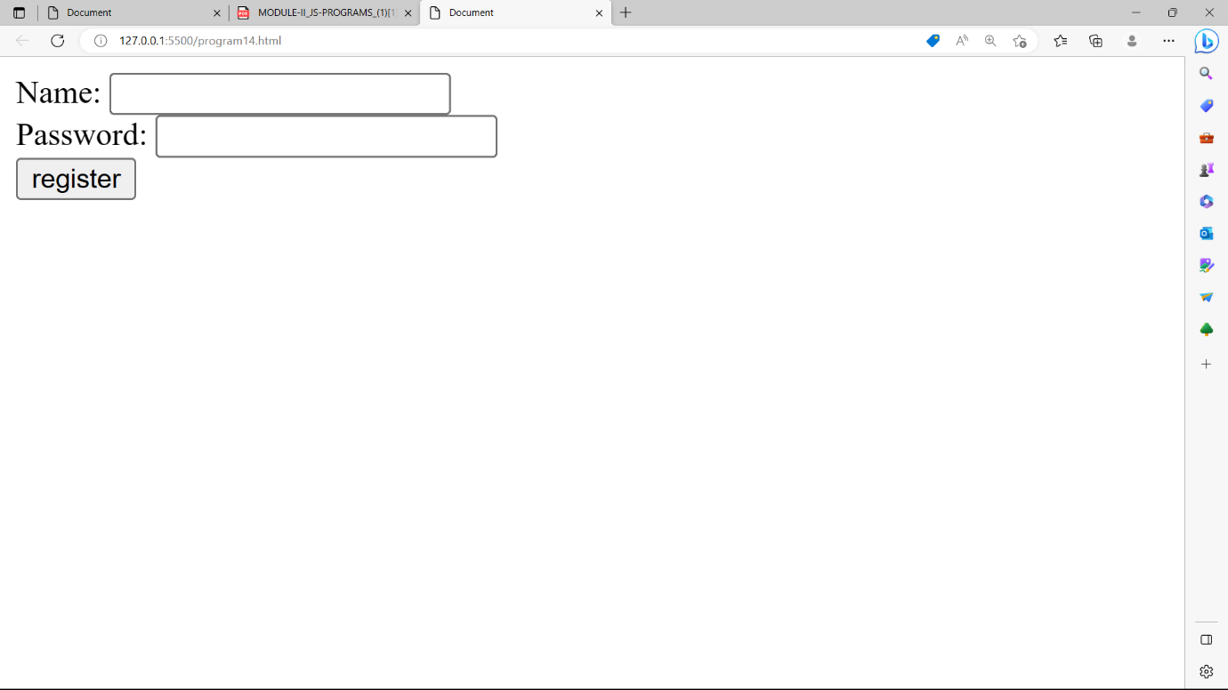

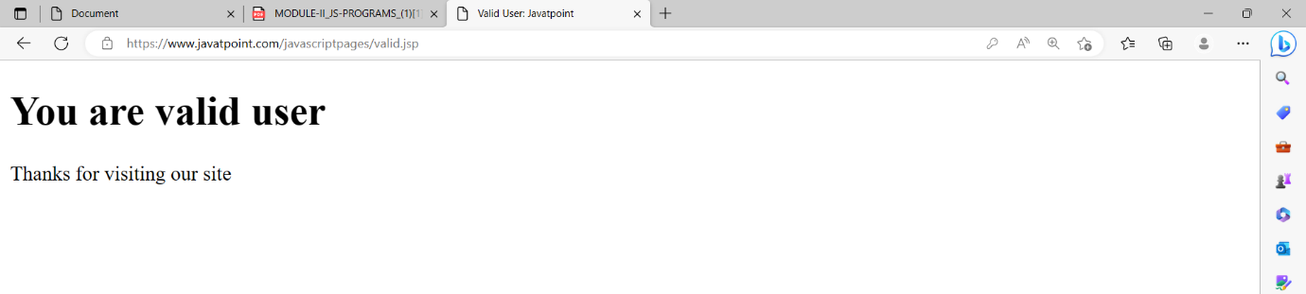

**EXPERIMENT-15:** Use JQuery hide() effect in page

**CODE:**

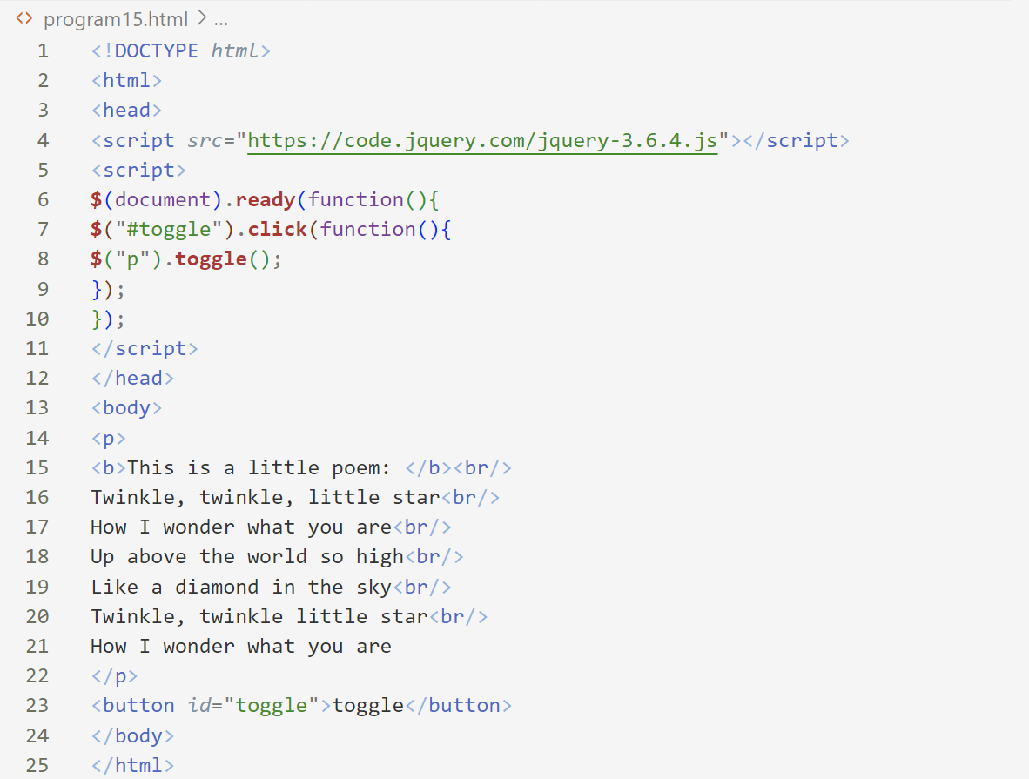

**OUTPUT:**

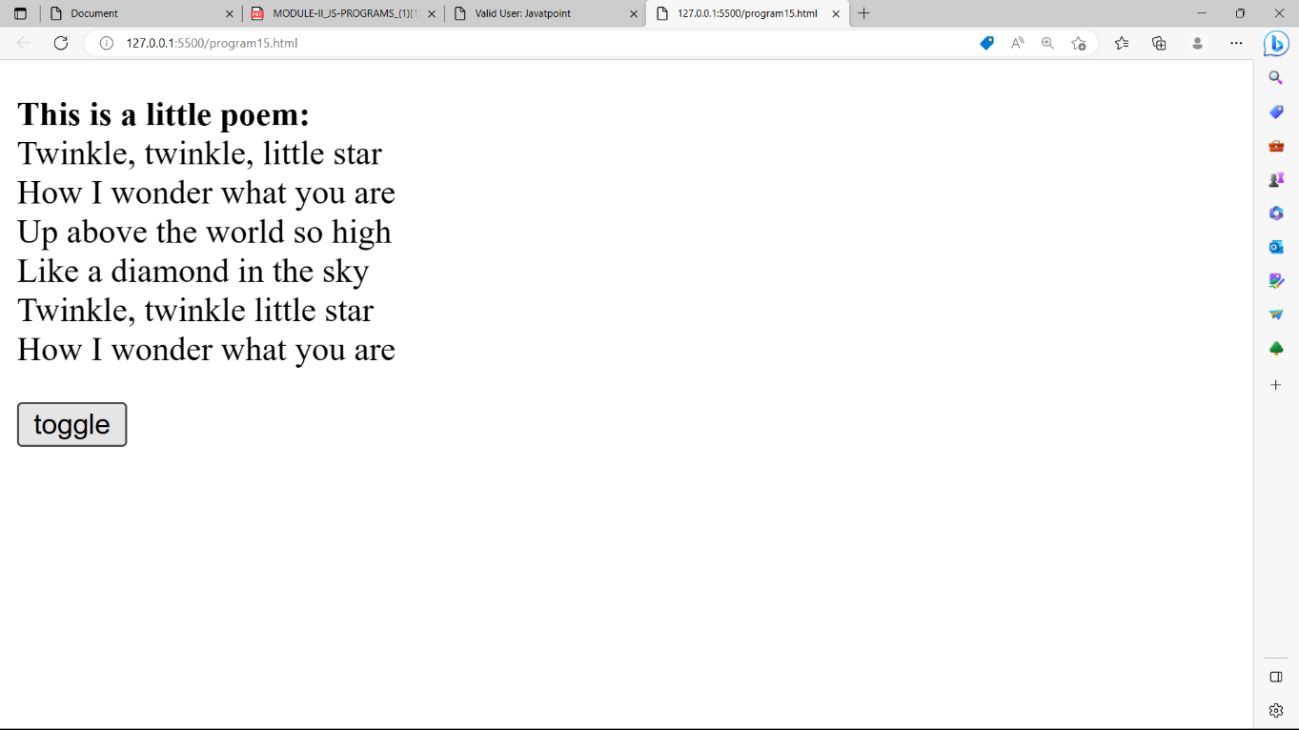

**EXPERIMENT-16:** Write a jQuery Code to Find the data passed with the on() method for each element.

**CODE:**

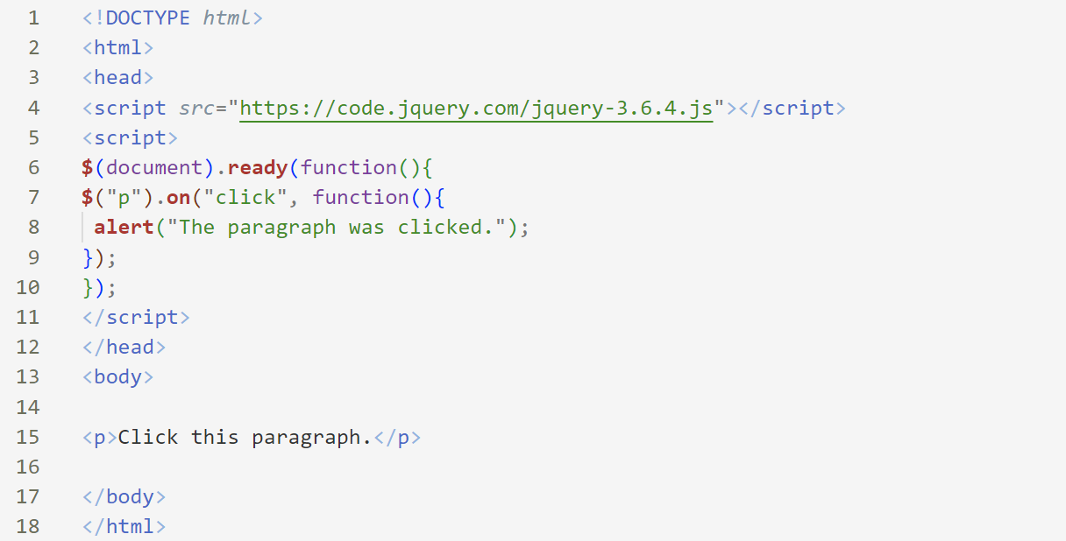

**OUTPUT:**

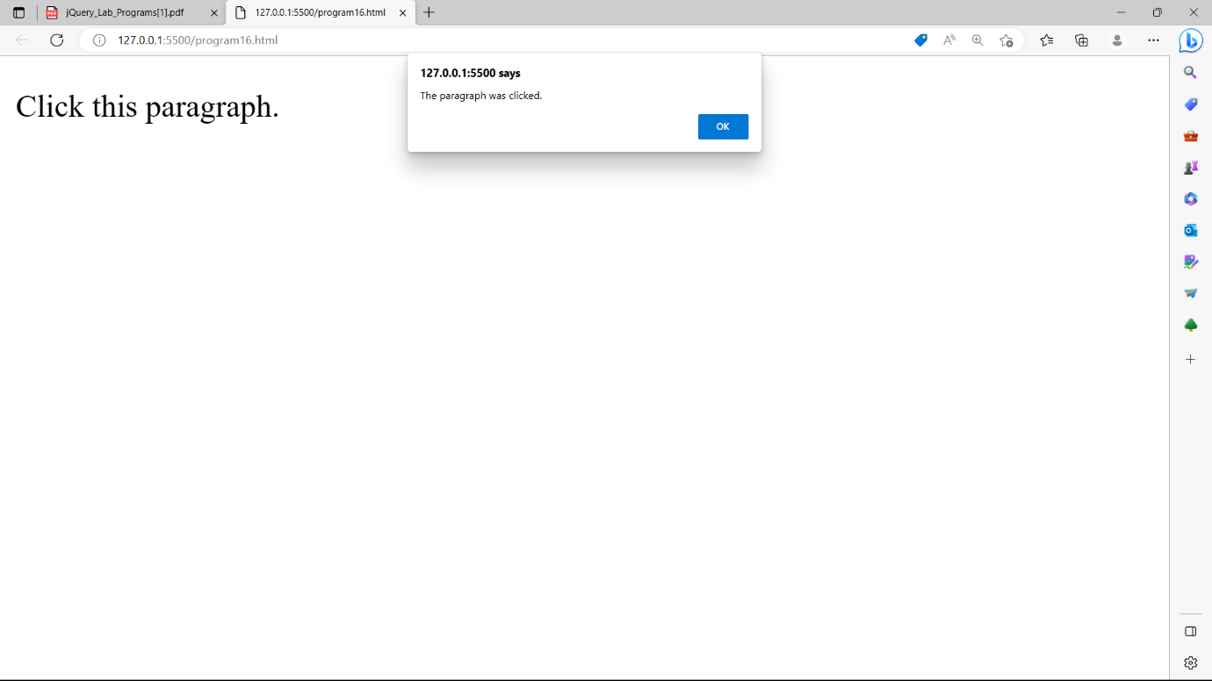

**EXPERIMENT-17:** Find the position of the mouse pointer relative to the left and top edges of the document.

**CODE:**

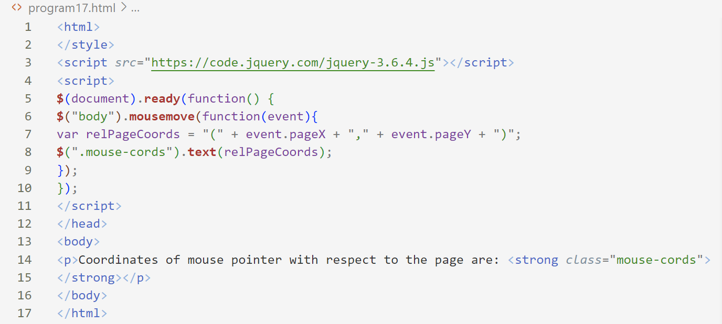

**OUTPUT:**

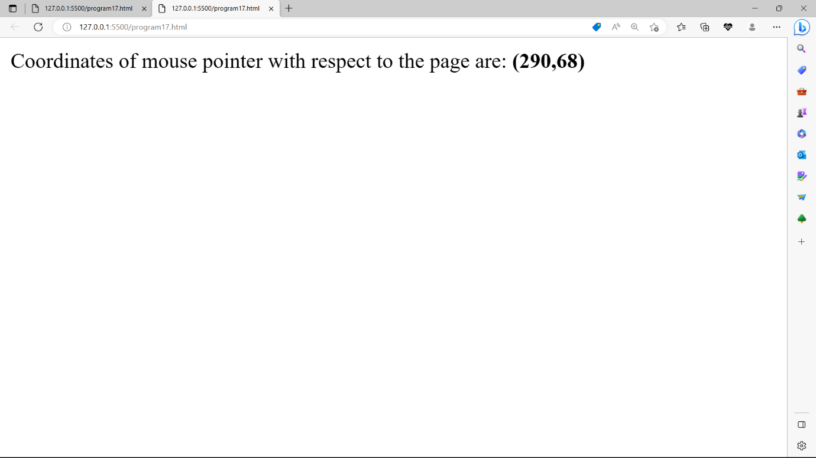

**EXPERIMENT-18:** Count the number of milliseconds between the two click events on a paragraph.

**CODE:**

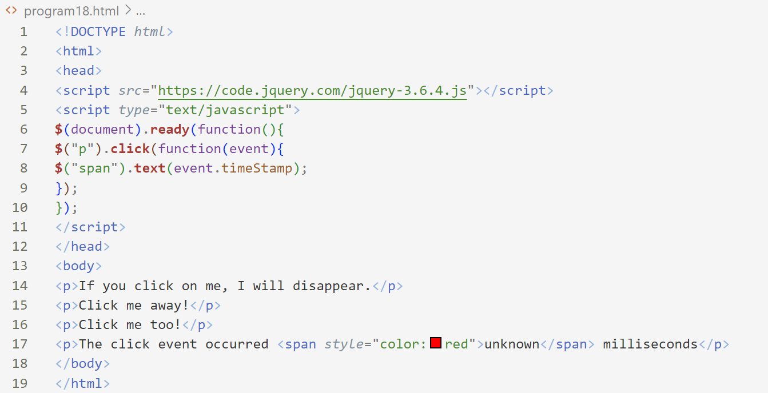

**OUTPUT:**

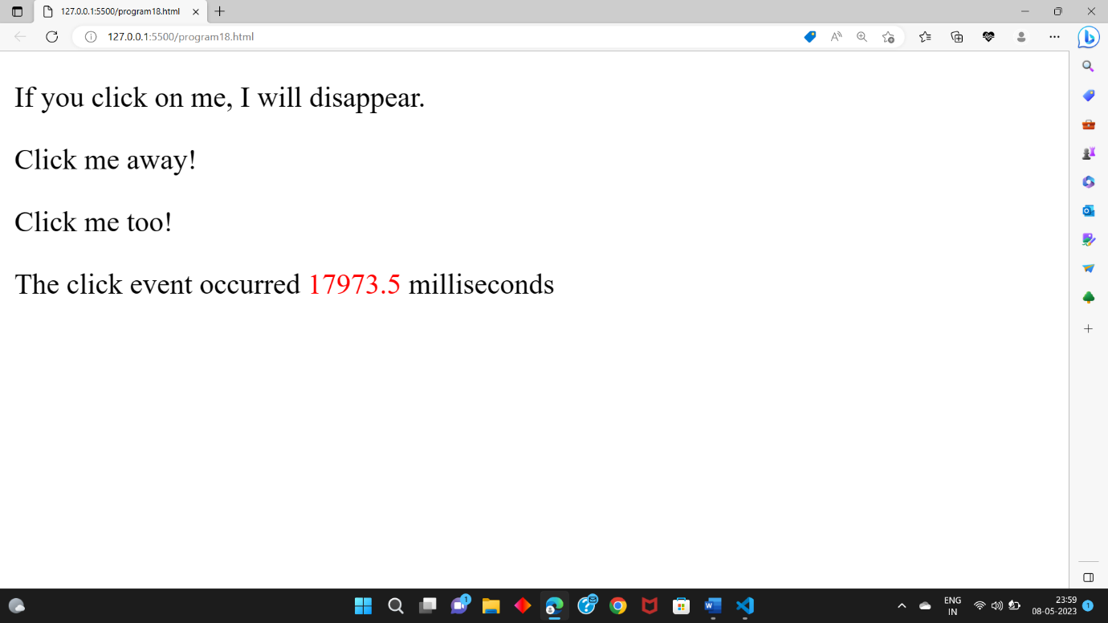

**EXPERIMENT-19:** Find all the text nodes inside a paragraph and wrap them with an italic tag.

**CODE:**

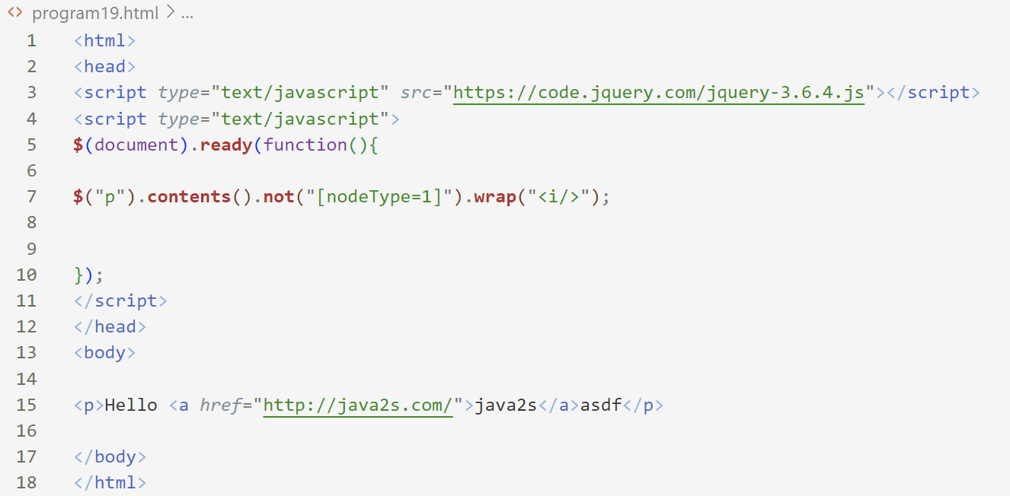

**OUTPUT:**

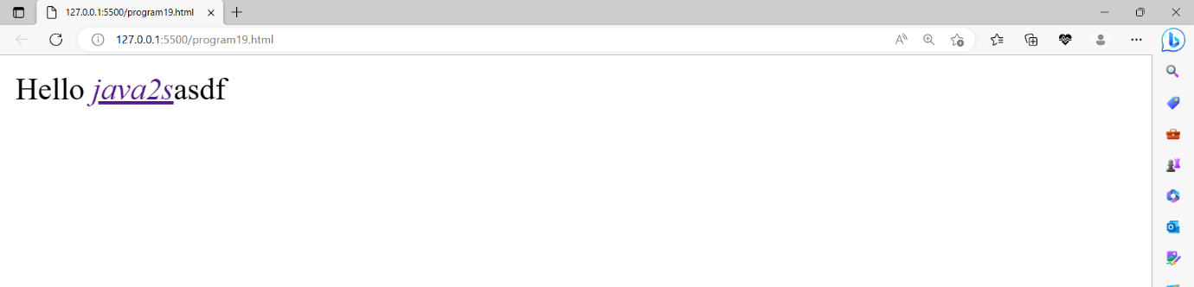

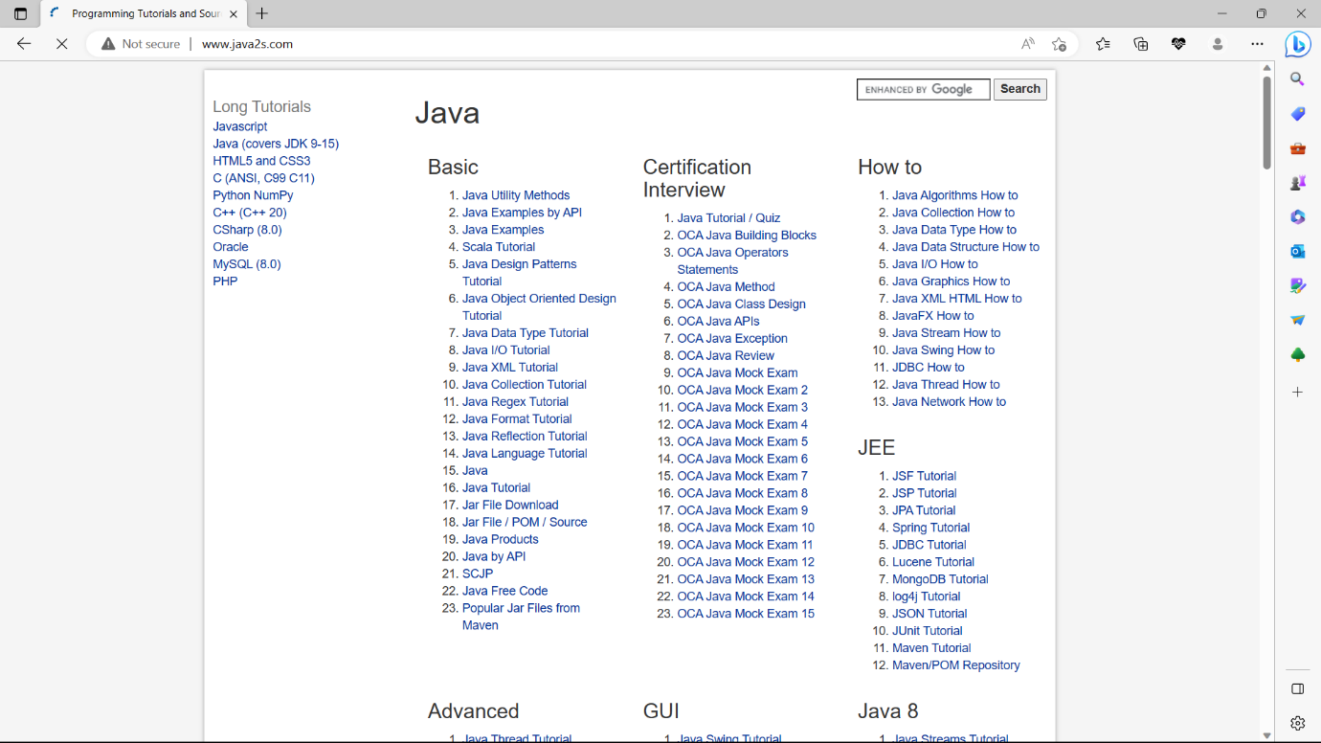

**EXPERIMENT-20:** Create an simple application using AJAX to show the table of numbers given by user at runtime.

**CODE:**

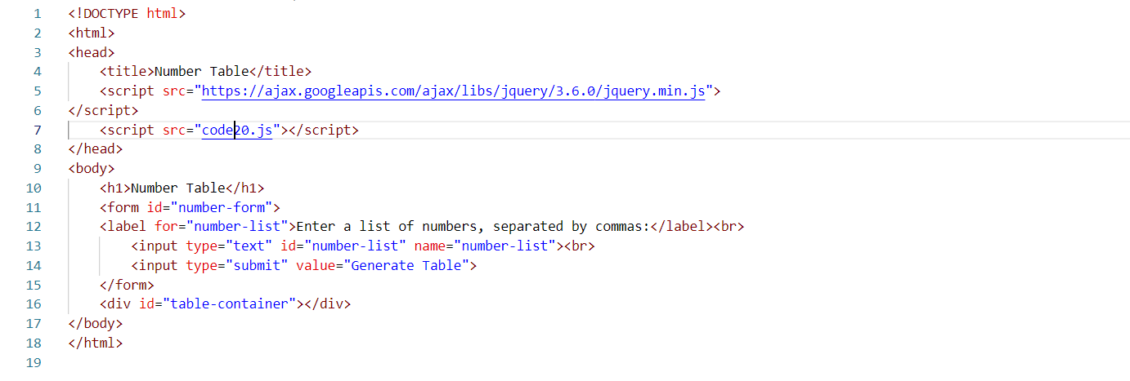

**CODE20.js**

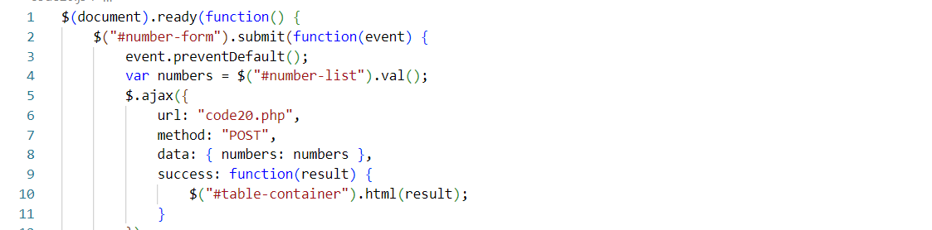

**CODE20.php**

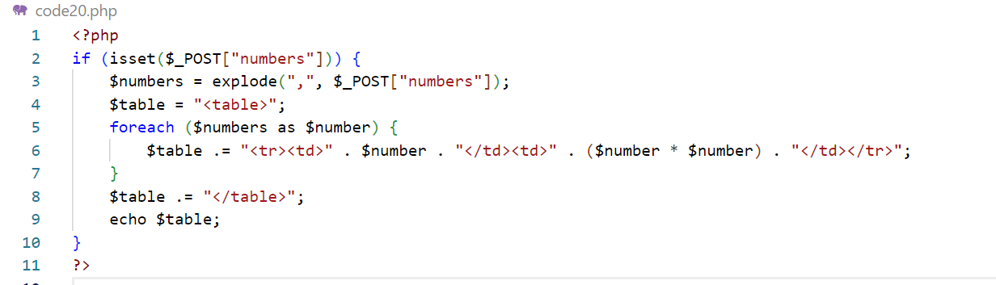

**OUTPUT:**

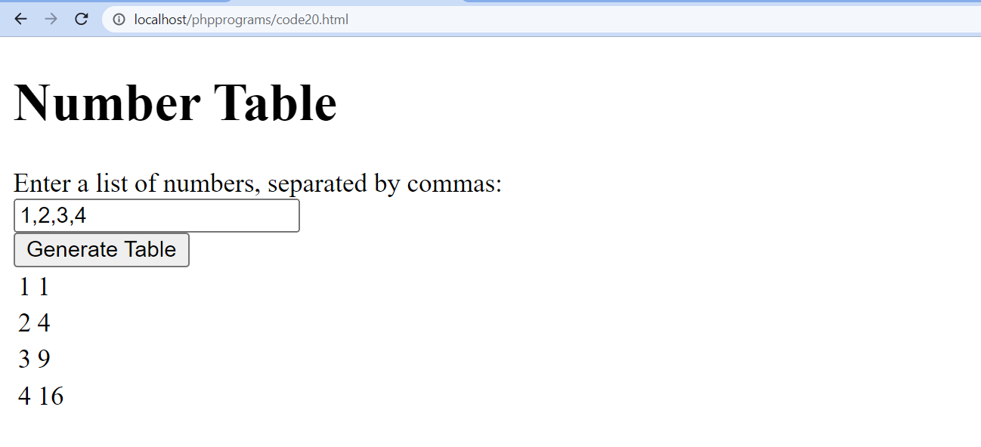

**EXPERIMENT-21:** Access web service using Ajax and handle using JSON.

**Code21.js**

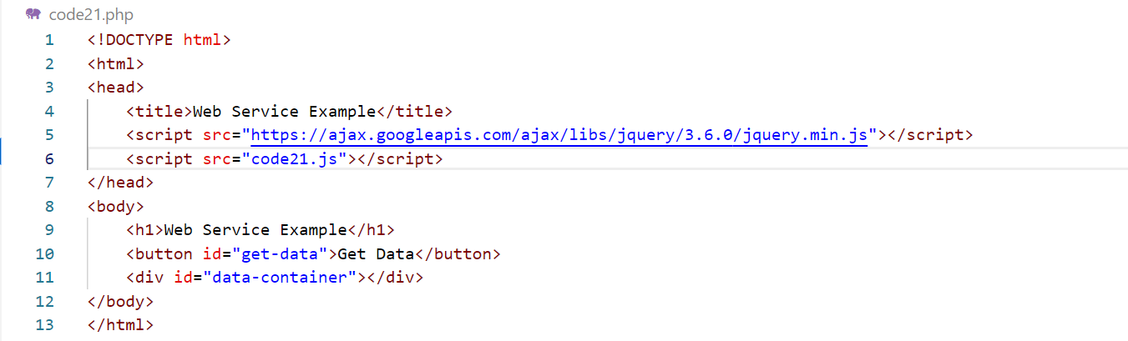

**Code21.php**

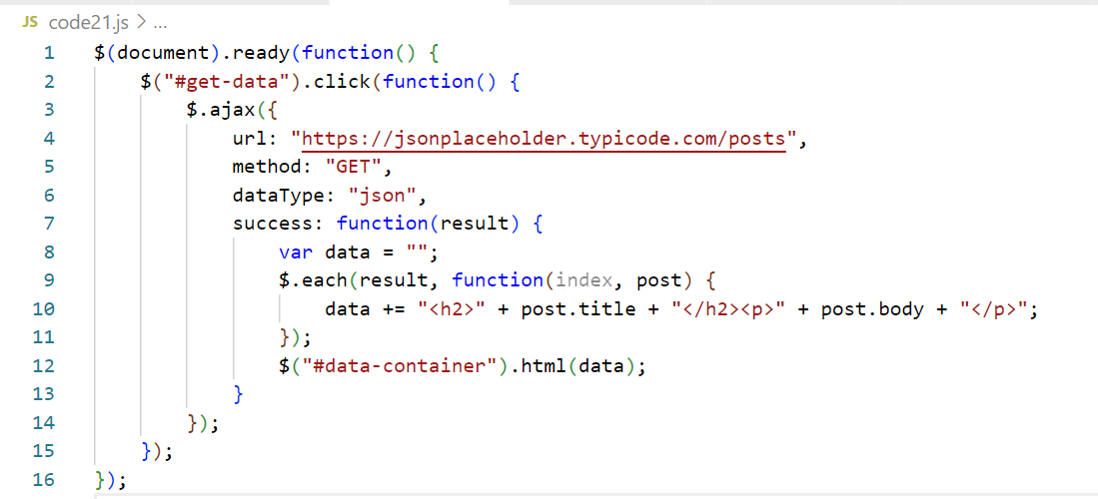

**OUTPUT:**

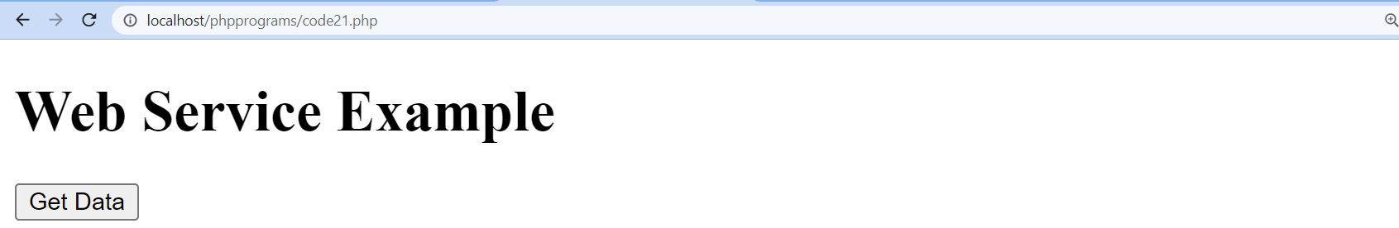

**EXPERIMENT-22:** Create a responsive website using bootstrap.

**CODE:**

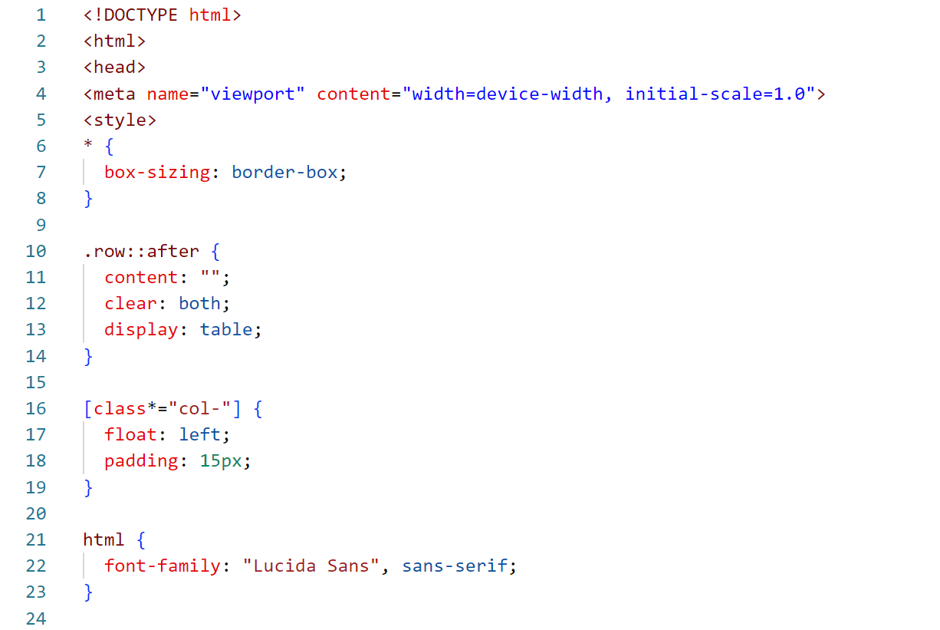

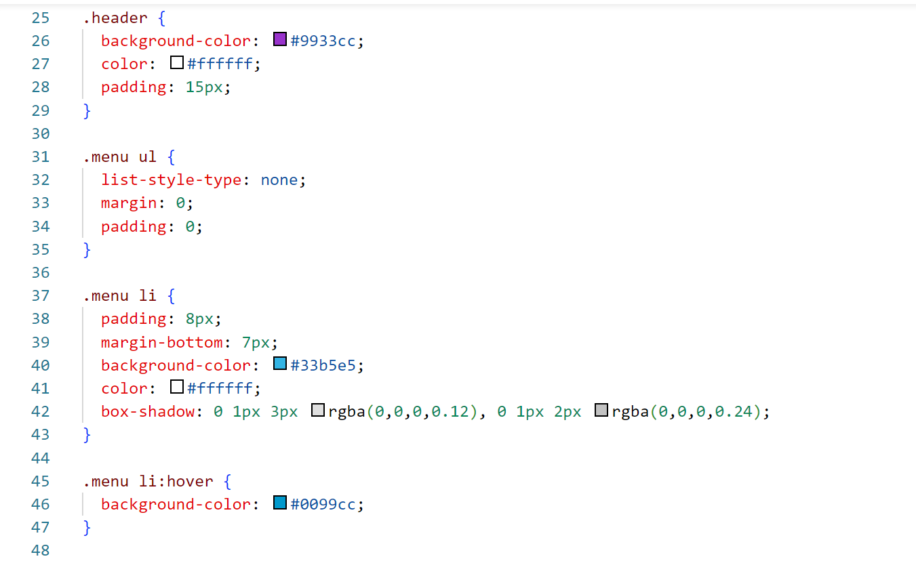

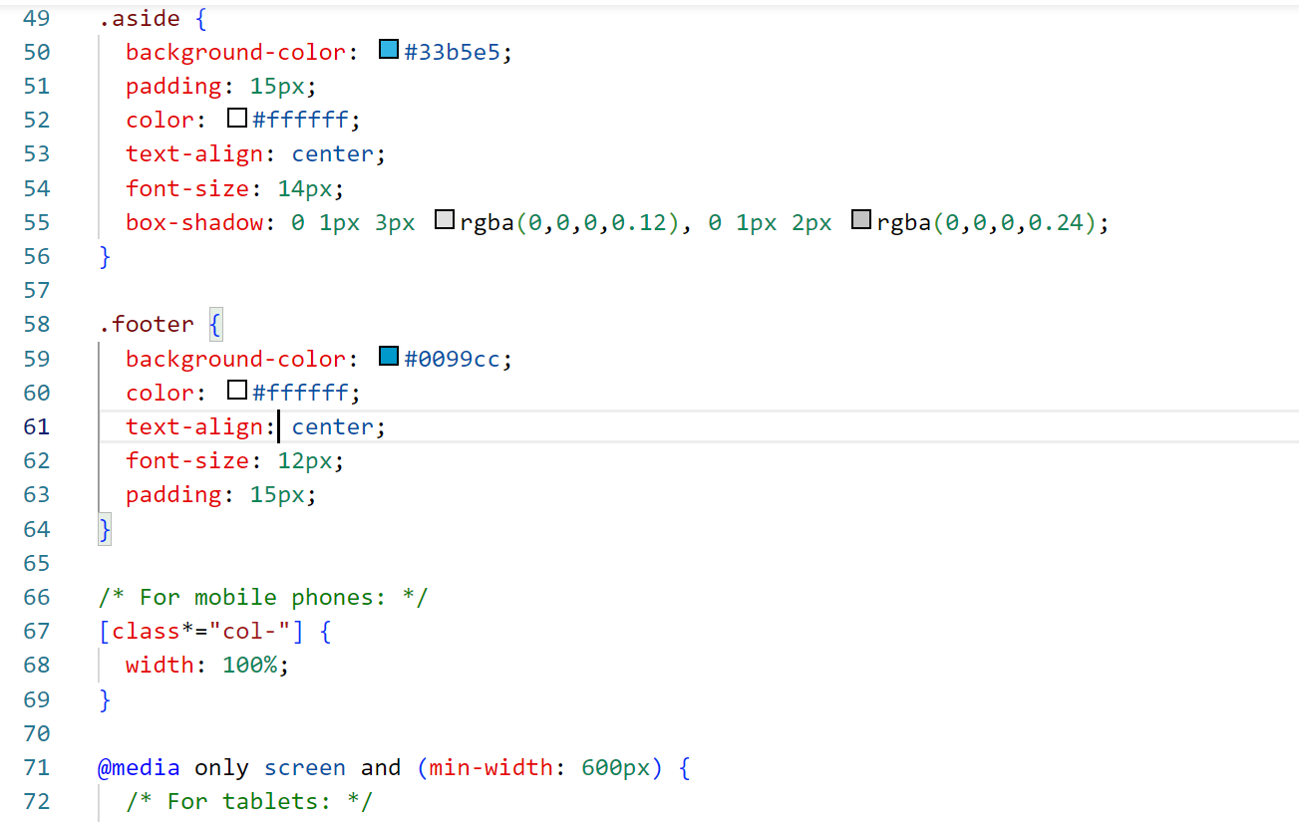

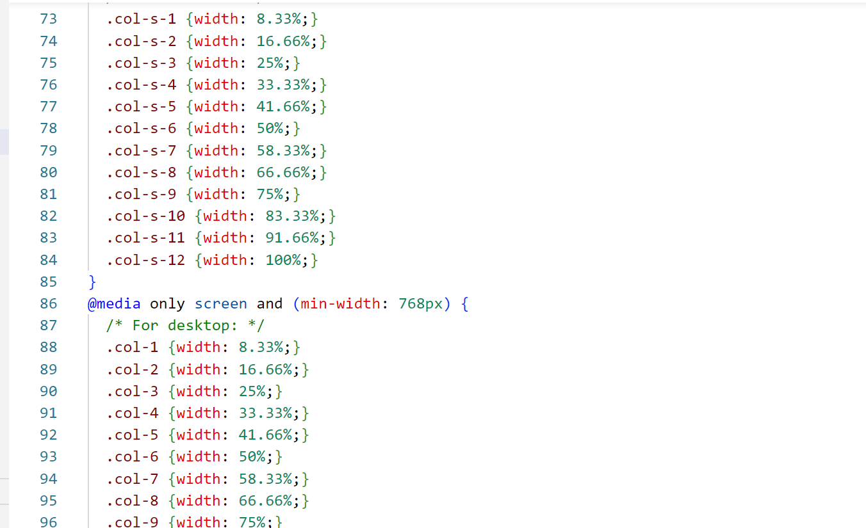

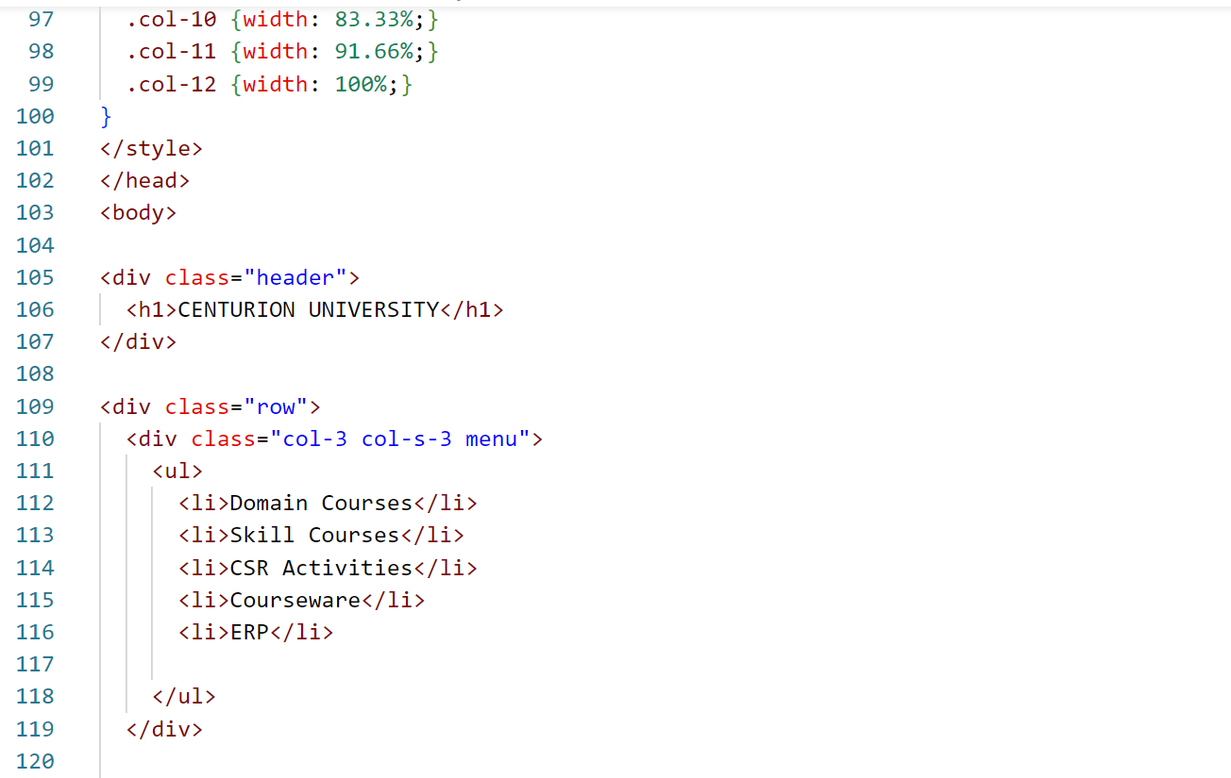

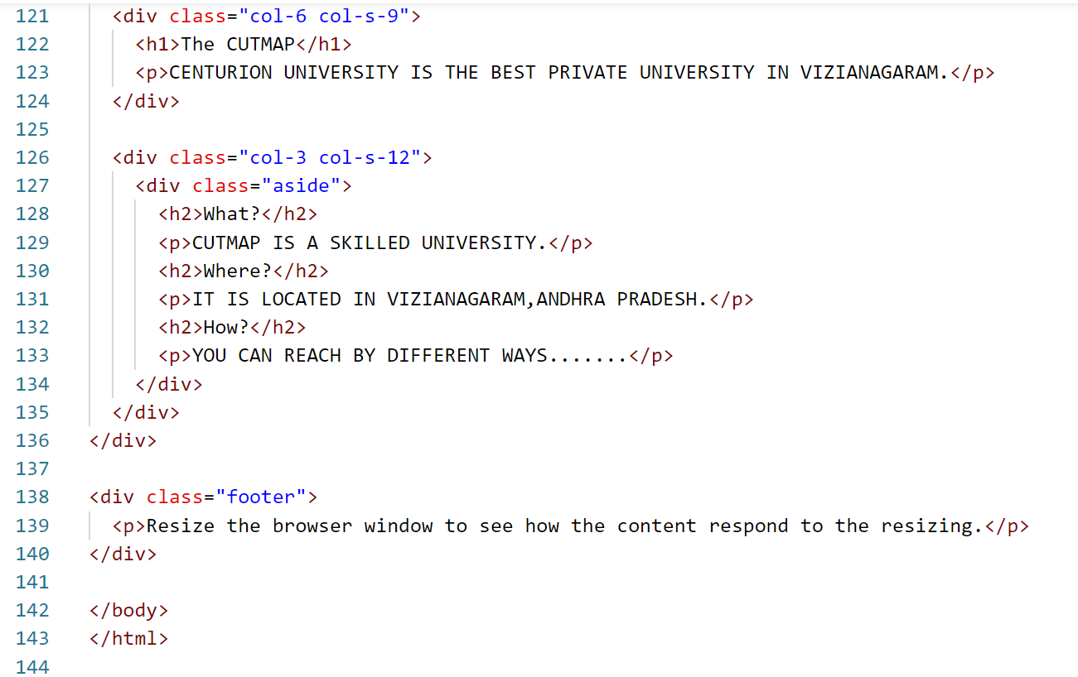

**OUTPUT:**

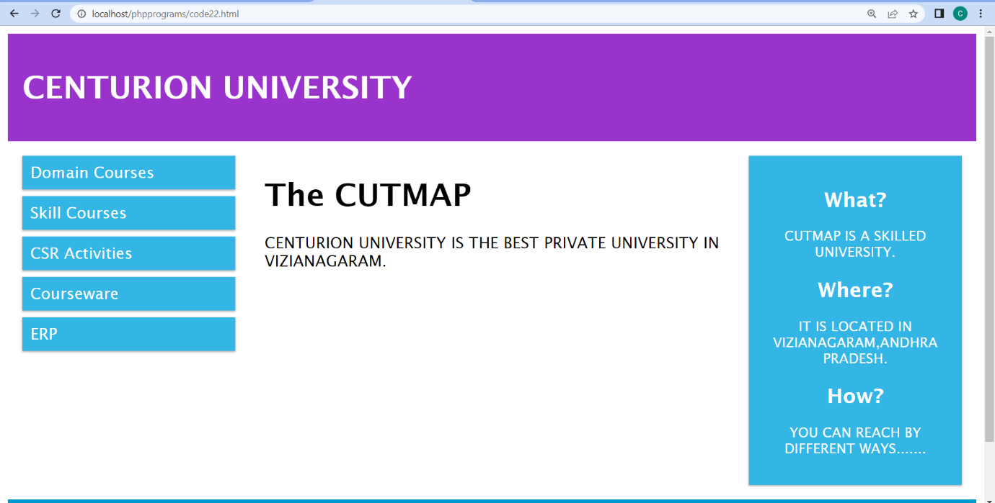

**EXPERIMENT-23:** Develop student registration web application using PHP.

**CODE:**

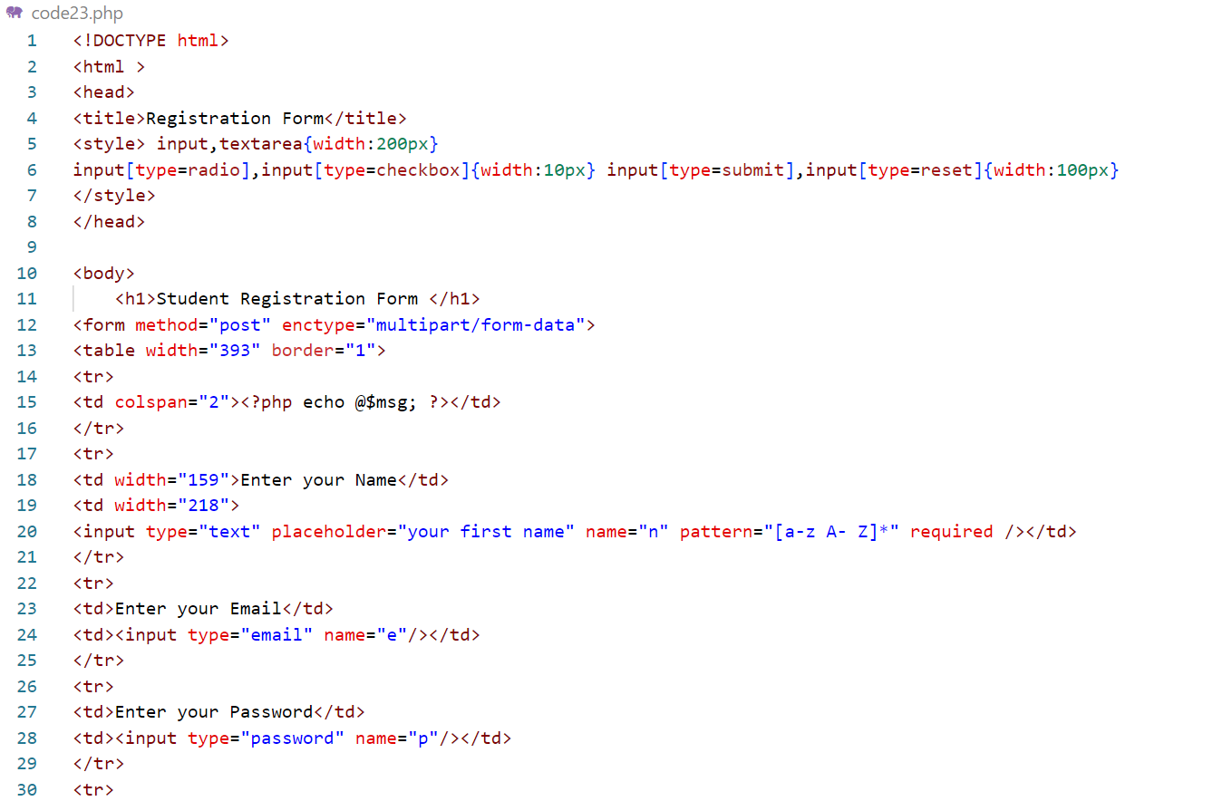

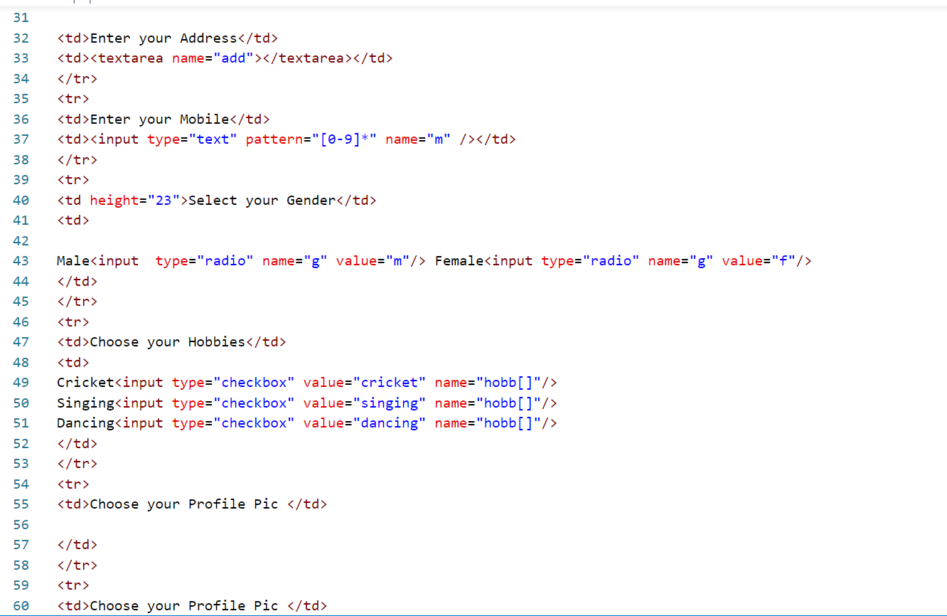

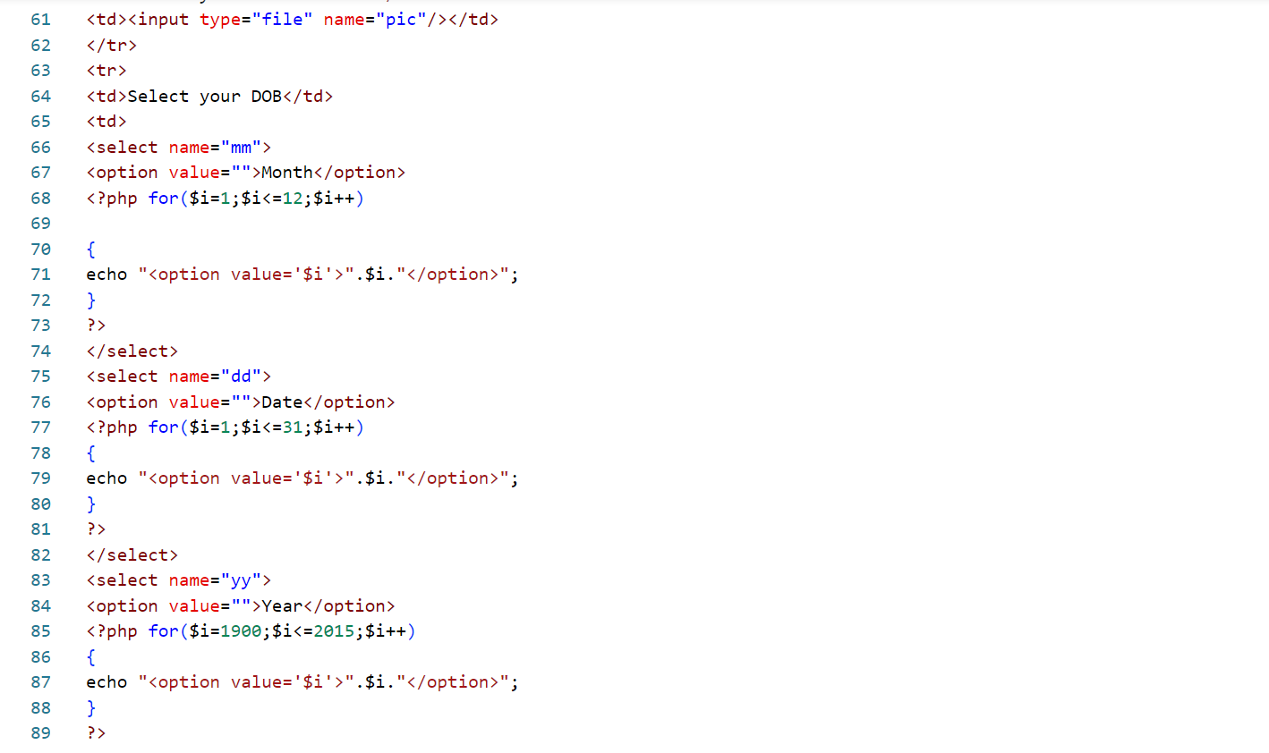

**OUTPUT:**

